**A SICKLE CELL DISEASE MANAGEMENT SYSTEM**.

By

GROUP 12

DEPARTMENT OF INFORMATION SYSTEMS

SCHOOL OF COMPUTING AND INFORMATICS TECHNOLOGY

A Project Report submitted to the School of Computing and Informatics Technology

For the Study Leading to a Project Proposal in Partial Fulfilment of the

Requirements for the Award of the Degree of Bachelor of Information Systems and

Technology of Makerere University

Supervisor

**Albert George Bitwire**

**(Mr.)**

Department of Information Technology

School of Computing and Informatics Technology, Makerere University

bitwire.albert@gmail.com

Telephone: +256-41-540628 Fax: +256-41-540620

July 2023

# Declaration

We GROUP 12(BIST 3, 2023), hereby declare to the best of our knowledge, that the findings in this report are a result of our study we made ourselves and they have never been published or submitted to any University for any degree award before.

|  |  |  |  |
| --- | --- | --- | --- |
| **#** | **Name** | **Registration number** | **Signature** |
| 1 | SENTONGO HAMZA | 20/U/3505/Ps |  |
| 2 | YIGA RODNEY | 20/U/1188 |  |
| 3 | NAMUSUSWA RACHAEL JFK | 20/U/1198 |  |
| 4 | AHIMBISIBWE JOB | 20/U/3480/Ps |  |
| 5 | SSEKITOLEKO ELISA | 20/U/3547/Ps |  |

# Approval

This report has been compiled and submitted by GROUP 12 (BIST 3, 2023) to Makerere

University for examination with the approval of;

Supervisor

|  |  |
| --- | --- |
| Signature:  .......................... | Date:  .......................... |

Albert George Bitwire (Mr.)

Department of Information Technology

School of Computing and Informatics Technology

Makerere University

# Dedication

This report is dedicated to all the group members of GROUP 12 (BIST 3, 2023) who took off time and hard work to make sure that this work was accomplished successfully. We further dedicate this report to our supervisor Albert George Bitwire (Mr.) who made himself available to us whenever we needed guidance, motivation and support. And also to the love, support and hard work that our parents have endlessly invested and showed to us. May God bless you all.

# Acknowledgement

First of all, we thank God Almighty for giving us great wisdom, courage and strength to carryon through our project. We glorify the name of the Lord for the perfect health and protection over our lives, none of us fell sick. Thank you Lord! We would like to also extend our utmost gratitude to our parents for their moral and financial support that necessitated the completion of this project. We are really grateful.

We wish to acknowledge the invaluable input of our supervisor, Albert George Bitwire (Mr.) who always reviewed our work and suggested changes as well as advising us on new input. His formidable efforts are highly commended. Thank you supervisor for having been patient with us and the support you have provided us with up to the submission of this project. In the same spirit of thanksgiving, we take this opportunity to thank the entire staff of the School of Computing & Informatics Technology for their various contributions to this project’s success through both technical and intellectual support all through our period of study.

Special thanks to all our friends for their views, knowledge and opinions that concerned our project. Their contributions were critical in providing information that made it possible to successfully put this project together.

For all the support offered unto us, we thank you and wish God’s peace that surpasses all human understanding to be with you.

Contents

Declaration ii

Approval iii

Dedication iv

Acknowledgement v

List of Tables ix

List of Figures x

List of Acronyms xi

Abstract xiii

1. Introduction 1

1.1 Introduction 1

1.2 Background 1

1.3 Problem Statement. 2

1.4 Objectives 2

**1.4.1 Main Objective** 2

**1.4.2 Specific Objectives** 2

1.5 Scope 3

**1.5.1 Functional Scope** 3

**1.5.2** **Geographical Scope** 3

**1.5.3** **Time Scope** 3

1.6 Research Significance 4

**1.6.1** **To the Sickle Cell Disease Patients and Care Takers** 4

**1.6.2** **To the Medical Facilitators or Doctors** 4

2. Literature Review 5

2.1 Introduction 5

2.2 Existing Systems 5

**2.2.1** **iCanCope Application** 5

**2.2.2** **MyMateMe Application** 6

**2.2.3 Dragon Exploration System for Sickle Cell Disease (DESSCD).** 7

**2.2.4 InCharge Application** 7

**2.2.5 iManage Application** 8

**2.2.6 Proposed System (Sickle Cell Disease Management System)** 9

2.3 Comparison with existing systems. 9

2.4 Conclusions 10

3. Methodology 11

3.1 Introduction 11

3.2 Requirements gathering 11

**3.2.1** **Sampling techniques** 11

**3.2.2** **Target population and sampling size** 11

3.3 Data Collection Methods 11

**3.3.1** **Interviews** 12

**3.3.2** **Questionnaires** 12

**3.3.3** **Document review** 12

3.4 System Development Methodology 13

**3.4.1 Rapid Application Development Rapid Application** 13

**3.4.2 Figma** 13

**3.4.3 Flutter Framework** 13

**3.4.4 Frameworks and Libraries** 14

4 System Study Analysis and Design 14

4.1 Introduction 14

4.2 System Study 14

**4.2.1 Strengths of Existing Systems** 15

**4.2.2 Weaknesses of Existing Systems** 16

**4.2.3 The Proposed System** 16

4.3 System Analysis 16

**4.3.1 Data Collection** 16

**4.3.2 Data Analysis** 17

**4.3.3 Requirements Analysis** 24

4.4 System User Requirements 24

4.5 Functional and non-Functional Requirements 25

**4.5.1 Functional Requirements** 25

**4.5.2 Non-functional Requirements** 26

4.6 High level Architecture of the developed system 29

4.7 The Flow Chart of the developed system 31

4.8 Context Diagram 32

**4.8.1 Level 1 Data Flow Diagram** 33

4.9 The Use Case Diagram 38

4.10 Enhanced Entity Relationship Diagram (EERD) 39

4.11 Dynamic Modeling 46

**4.11.1 Activity Diagrams** 46

**4.11.2 Sequence Diagrams** 47

**4.11.3 Collaboration Diagrams** 53

**4.11.4 State chart Diagrams** 54

System Implementation, Testing, and Validation 56

5.1 Data Outputs 56

**5.1.1 System Forms** 56

5.2 Programming Languages Used 67

**5.2.1 Web Application Programming Languages** 67

**5.2.2 Mobile Application Programming Languages** 67

5.3 The Tools 68

**5.3.1 Web Development Tools** 68

**5.3.2 Mobile App Development Tools** 69

5.4 System Testing 69

**5.4.1 Unit Testing** 69

**5.4.2 Integration Testing** 69

**5.4.3 System Testing** 70

**5.4.4 User Acceptance Testing** 70

5.5 Validation 70

5 Discussion, Recommendations, Future work and Conclusions 71

6.1 Discussion 71

6.2 Limitations 71

6.3 Recommendations Future work 72

6.4 Conclusion 72

References 73

Appendices 75

# List of Tables

Table 2. 1: Comparison of the existing system with the proposed system 10

Table 4. 1: Respondents from interview sessions and questionnaires 17

Table 4. 2: Software requirements of the system 28

Table 4. 3: Hardware requirements of the system 28

Table 4. 4: Process modelling Symbols and their Descriptions 35

Table 4. 5: Entities and their Descriptions 37

Table 4. 6: Processes and their Descriptions 37

Table 4. 7: Data stores and their Descriptions 38

Table 4. 8: Database Design 46

# List of Figures

figure 4. 1: Analysis of respondent patients/ caregivers 18

figure 4. 2: Analysis of respondent monthly attendance and re-attendance 19

figure 4. 3: Analysis of how often respondents visit the doctors 20

figure 4. 4: Analysis on how respondents currently communicate with the doctors 20

figure 4. 5: Analysis on the system features required by the respondents 21

figure 4. 6: Analysis showing use of systems in sickle cell management 22

figure 4. 7: Analysis on how doctors communicate with the patients / caregivers 23

figure 4. 8: Analysis on how doctors see or receive patients/ caregivers 24

figure 4. 9: Mobile phone architecture 29

figure 4. 10: Web app architecture 30

figure 4. 11: Flow Chart Diagram 31

figure 4. 12: Context Diagram 32

figure 4. 13: Level 1 Data Flow Diagram 35

figure 4. 14: Use Case Diagram 39

figure 4. 15: Enhanced Entity Relationship Diagram 43

figure 4. 16: Activity Diagram 47

figure 4. 17: Registration process 48

figure 4. 18: Login process 49

figure 4. 19: Appointment Process 50

Figure 4.2 1: Messaging process 52

Figure 4.2 2: Collaboration Diagram 53

Figure 4.2 3 : State Chart Diagram 55

figure 5. 1: Showing a Patient / Care giver Registration form. 57

figure 5. 2: Showing the Appointment Form 58

figure 5. 3: Showing the Medication Form 59

figure 5. 4: Showing the Weekly Report Form 60

figure 5. 5: Showing the Communication Form 61

figure 5. 6: Showing the Login Interface of the System. 62

figure 5. 7: Showing the Appointment List Interface of the System. 63

figure 5. 8: Showing the Medication List Interface of the System. 64

figure 5. 9: Showing the Weekly Report List Interface of the System. 65

figure 5. 10: Showing the Chat Room Interface of the System. 66

# Appendix List

Time framework budget for the development of the Sickle Cell Disease Management System 75

Financial budget for the development of the Sickle Cell Disease Management System 75

Data collection Instruments. 76

**Questionnaire with closed questions.** 76

**Questionnaire with Open questions** 78

Interview Questions 79

# List of Acronyms

Adobe XD: Adobe Experience Design

Ajax: Asynchronous JavaSript And XML

CBT: Cognitive Behavior Therapy

CDC: Center for Disease Control

CSS: Cascading Style Sheets

DBMS: Data Base Management System

DESSCD: Dragon Exploration System for Sickle Cell Disease

DFD: Data Flow Diagram

EERD: Enhanced Entity Relationship Diagram

EHR: Electronic Health Record

ER: Entity Relationship

etc: et cetera

GB: Giga Byte

GDPR: General Data Protection Regulation

HIPAA: Health Insurance Portability and Accountability Act

HTML5: Hypertext Markup Languange (Version 5)

iOS: Iphone Operating System

LBD: Literature Based Discovery

MOH: Ministry of Health

MySQL: My Structured Query Language

PHP: Hypertext Pre-processor

QR: Quick Response

RAD: Rapid Application Development

RAM: Random Access Memory

SCD: Sickle Cell Disease

SPSS: Statistical Package for Social Sciences

SQL: Structured Query Language

UI/UX: User Interface/ User Experience

USCRF: Uganda Sickle Cell Rescue Foundations

USSD: Unstructured Supplemetary Service Data

# Abstract

Effective communication and coordinated care play a vital role in managing chronic conditions such as sickle cell disease (SCD). This comprehensive sickle cell management system designed to improve communication between doctors and patients during outpatient care. The system incorporates various features, including embedded reminders, a treatment plan module, and a prescription module, aimed at enhancing patient care and treatment outcomes. The primary objective of the sickle cell management system is to establish seamless communication channels between healthcare providers and patients, ensuring that critical information is exchanged efficiently and effectively. The system facilitates secure and real-time messaging, allowing doctors to address patient concerns promptly and enabling patients to seek medical advice conveniently. One of the key components of the system is the embedded reminder feature, which helps patients adhere to their treatment plans and medication schedules. Timely reminders ensure that patients take their prescribed medications on time, reducing the risk of complications associated with SCD. Furthermore, the system assists healthcare providers in monitoring patients' adherence to treatment plans, enabling timely interventions when necessary. Design methods such as process modelling, functional modelling and data modelling were used in the system analysis & design phase. The implementation was done with programming languages such as Dart in the flutter framework.

In conclusion, the Sickle Cell Disease Management system offers a comprehensive solution for improving communication and care in outpatient settings. By integrating embedded reminders, treatment planning, and a prescription module, the system aims to enhance patient engagement, medication adherence, and overall treatment outcomes for individuals living with sickle cell disease. Its implementation has the potential to revolutionize the management of SCD, fostering a collaborative and patient-centered approach to care.

**Chapter 1**

# Introduction

## 1.1 Introduction

The emergency of real-time healthcare management systems that offer remote and personal healthcare services has become vital with the existence of a few Sickle Cell Disease

Systems for example the Doctor’s Appointment System in Mulago Sickle Cell Clinic. Patients with Sickle Cell Disease (SCD) require continuous services of testing, following up and monitoring. Offering these services to patients smoothly at any time leads to the need for an integrated healthcare system. The recent development in information systems and technologies facilitate the introduction of such healthcare systems. (Abd , Al-Mejibli 2017).

## 1.2 Background

Sickle Cell Anemia is a very complex and difficult disease to manage. Sickle cell disease (SCD) is a blood disorder present at birth, over 300,000 babies worldwide are born each year with these disorders. In Uganda, 20% of the population have the genetic trait of sickle cell disease while 20,000 babies are born each year with the genetic defect (MOH, 2019). People with SCD have “sickle" shaped red blood cells that stick together and block blood and oxygen from reaching all parts of the body, leading to health problems such as pain, anemia, infections, and stroke. This disease is being caused when both parents carry one copy of the sickle cell gene also known as sickle cell trait and pass both copies of the altered form to the child.

According to Dr Deogratias Munube Head of Department Mulago Sickle Cell Clinic “There are currently two systems being used, one for making appointments and another one for tracking documents of the sickle cell patients through having a database to keep their information".

However, doctors seldom follow up patients after their visit at the hospital since they only offer outpatient care hence leaving the burden of proper management of the disease to the patients.

The sickle cell disease has continued to claim lives of its patients in Uganda and there’s still a need of proper treatment and management or care of the patients so as to reduce the burden the disease poses on the patients. Centre for Disease Control (CDC) is committed to studying Sickle Cell Disease to improve the health and care of people with this condition. The proposed Sickle cell Disease management system advocates for an online platform to bridge the communication gap between the health personnel and their patients together with integration of various services to improve on the lifestyle of the sickle cell patients.

The system will provide services such as weekly progress reports, chatrooms, support groups forums, appointment reminders, recording blood transfusion details and hospitalization details and medication timetabling.

## 1.3 Problem Statement.

In Uganda today, there are communication difficulties experienced between sickle cell disease patients or caregivers and their health personnel. Sickle cell patients in Uganda largely depend on outpatient care with periodic visits to different health centers, this has left the caregivers and the patients open to poor management of the disease as they are left unaware of how to go about emergency situations like pain episodes, stroke organ failure and anemia. This has led to a high mortality rate of up to 90% of children dying before reaching the age of five, poor quality of life and morbidity, an increase in the discrimination rate of Sickle Cell Patients raising 53% (Oyedeji, Strouse, 2020) worldwide as well as less interaction among sickle cell patients of different levels (adults, middle-aged and newborns), fear of the unknown, stigma from the environment and some financial burdens which lead to poor nutrition in many families with sickle cell patients leading to increased possibilities of unexpected attacks. (Atoku et al 2022). The sickle cell Disease management system is to bridge the communication gap between caregivers or patients and medical personnel.

## 1.4 Objectives

### **1.4.1 Main Objective**

To develop an online Sickle Cell Disease Management System.

### **1.4.2 Specific Objectives**

1. To review literature and conduct field study about the existing Sickle Cell Disease Management systems.
2. To design the model for the Sickle Cell Disease Management System.
3. To implement the Sickle Cell Disease Management System.
4. To test and validate the Sickle Cell Disease Management System based on the requirements.

## 1.5 Scope

### **1.5.1 Functional Scope**

The study concentrated on the development of a Sickle Cells Disease Management System specifically to ease the communication between Sickle Cell patients or caregivers and the concerned medical persons during the period a patient is waiting for the next appointment through submitting weekly progress reports and seeking advice about the different abnormal signs hence reducing the burden of managing the disease.

### **Geographical Scope**

The study was conducted at Mulago Sickle Cell Disease clinic, which receives the biggest number of sickle cells patients and the Uganda Sickle Cell Rescue Foundations (USCRF) in Kampala district.

### **Time Scope**

* We reviewed literature and conducted field study about existing Sickle Cell Disease Management systems - Duration: 4 weeks (from Week 1 to Week 4).
* We designed the model for the Sickle Cell Disease Management System - Duration: 6 weeks (from Week 4 to Week 10).
* We implemented the Sickle Cell Disease Management System - Duration: 10 weeks (from Week 10 to Week 20).
* We tested and validated the Sickle Cell Disease Management System based on the requirements - Duration:7 weeks (from Week 20 to Week 27)
* Documentation of the final report - Duration: 3 weeks (from Week 27 to Week 30)
* The overall estimated time scope for the project was approximately 30 weeks

## 1.6 Research Significance

### **1.6.1 To the Sickle Cell Disease Patients and Care Takers**

The Research is to help the Sickle Cell patients by providing them with a secure platform of easily communicating with the doctors within the period they are set for the next appointment at the hospital, sickle cell information and reminders to reduce unintended defaulting. The patients will still be able to submit weekly reports to the doctors on their health progress as well as communicating with other patients and the support groups in case of help.

### **1.6.2 To the Medical Facilitators or Doctors**

The doctors will be able to communicate with their patients in time through the weekly reports which will be submitted by the patients via the system. The system will also be able to provide doctors with the weekly report analysis. Still the doctors will be able to provide emergency information to the patients in case of the sickle Cell attack hence reducing on the number of sickle Cell emergencies which will be admitted in different clinics.

**Chapter 2**

# Literature Review

## 2.1 Introduction

This chapter encompasses a wide range of critically reviewed research work from projects already done about Sickle Cell disease medication and monitoring systems. This is done to acknowledge contributions from other researchers and also reveal weaknesses and gaps into the existing systems.

It focused on existing platforms based on Sickle Cell disease medication and monitoring systems alongside the proposed system (Sickle Cell Management system) that is expected to become a secure solution for communication difficulties for most sickle cell patients and also ease their medication. A review of prior, relevant literature is an essential feature of any academic project. An effective review creates a firm foundation for advancing knowledge. It facilitates theory development, closes areas plethora of research exists, and uncovers areas where research is needed (Webster & Watson, 2002).

## 2.2 Existing Systems

### **2.2.1 iCanCope Application**

The iCanCope app is a platform that was initially developed for youth with chronic pain and has been adapted for this trial for youth with sickle cell disease (SCD). The program includes pain self-management skills training, goal setting, and social support, and is designed to enhance self-efficacy and it is developed natively for iOS and Android smartphones and the website is accessible on all modern web browsers.

The program is restricted to study participants, and detailed user level and aggregate analytics will be captured to track user engagement.

The app has four key features which are, daily symptom tracking, goal setting, self management skill library, and social community.

**Strengths**

The strengths include its ability to deliver an evidence-based pain self-management intervention for youth with SCD, its ability to address the barriers to CBT for SCD pain such as geographic restrictions, limited availability of clinicians trained in CBT for SCD pain, direct and indirect incurred costs of additional healthcare visits, and the stigma associated with seeking assistance through mental health services. The study is novel in its use of user-centered design principles and active engagement of youth with SCD in the development process, which is expected to address some of the participation barriers and improve engagement and cultural and linguistic appropriateness.

**Weaknesses**

The weaknesses of the iCanCope app could be the potential lack of engagement from users due to the self-management aspect of the program. It also relies on the accessibility and availability of smartphones and internet connection for the app to be used effectively.

### **2.2.2 MyMateMe Application**

The app is designed to help patients by providing a variety of features that encourage engagement and education. The main feature of the app is the Avatar feature, where a cartoon figure of a boy or girl accompanies the patient throughout their interaction with the app. Patients can earn bonus points by being active in various app sections and use them to dress the avatar with new clothes, accessories, or even facial hair. This feature is a strength of the app as it allows patients to personalize their experience and make it more engaging.

**Strengths**

Its strengths include the Avatar feature, the Tip of the Day feature, the Daily Quiz feature, the Mood Tracker feature, and the Medication and Appointment Reminders feature, there’s also an Emergency section.

**Weaknesses**

Its weaknesses include that it may not be suitable for patients who have difficulty using a mobile device or who have a visual impairment and that it may not be effective for patients who do not find the avatar feature engaging.

### **2.2.3 Dragon Exploration System for Sickle Cell Disease (DESSCD).**

The Dragon Exploration System for Sickle Cell Disease (DESSCD) is a resource developed to facilitate the discovery of disease-modifying drugs and curative strategies for sickle cell disease (SCD) through the analysis of published biomedical literature. The system is based on text mining and data mining and has been developed to make it easy for researchers to explore SCD related data.

**Strengths**

Strengths of DESSCD include its ability to automatically distil information, extract concepts, discover implicit links by association between the concepts, and generate hypotheses. This feature is known as ‘Text-Based Knowledge Discovery’ or ‘Literature Based Discovery (LBD)’. Additionally, DESSCD is the first resource specifically developed for exploring associations between biomedical SCD-related concepts.

**Weaknesses**

Weaknesses of the system include that its precision and recall for identified concepts from “Human Genes and Proteins" dictionary is lower than the other dictionaries, with precision, recall and F-measure of 81.1%, 96.1% and 87.9%, respectively.

### **2.2.4 InCharge Application**

This is a mobile Health intervention for individuals with Sickle Cell disease to improve adherence to Hydroxyurea using a centered design. This is to reduce on the barriers to Hydroxyurea adherence by patients which include the increased forgetfulness and several specific thoughts and emotions associated with Hydroxyurea use (e.g. fear of the side effects, depression, stigma and hopelessness) thus to improve the quality of life and Health outcomes amongst patients. (Nicole, et al 2020)

**Strengths**

The Mobile Application involved the medication reminders and trackers, disease education, communication, personalization, motivation, support during the pain episodes, setting individual motivational goals and social support.

**Weakness**

Several participants indicated that they would like to have reminders within the application basing on the customization according to their personal preferences. The Application is not able to track other medication progress apart from Hydroxyurea.

The ability of an application not being able to connect patients with other friends and their family members. The ability of the patients using the Application not being able to communicate with their medication team during crisis periods.

### **2.2.5 iManage Application**

The iManage for SCD is a mobile application that aims to improve self-management and self-efficacy for adolescents and young adults with Sickle Cell Disease. The app allows users to record progress on their self-management goals, log pain and mood symptoms, and receive reminders to stay on track. The app was developed through a co-creation process with adolescents and young adults with SCD and medical providers to match the needs and preferences of the target population.

**Strengths**

The use of the mobile app to track daily pain, fatigue, and mood symptoms, which has the potential to provide real-time data on symptoms and improve self-management.

The inclusion of peer support and action planning as key components of the intervention, which can increase motivation and engagement in self-management.

**Weaknesses**

The app is mostly used by older adolescent and young adults than the younger cohort, which suggests that the app may not have been fully developmentally appropriate and may need additional tailoring for different age groups.

### **2.2.6 Proposed System (Sickle Cell Disease Management System)**

Basing on the information and the different activities that are being done by the existing system in the Sickle Cell Disease fight in different countries, there is still a big gap especially in Uganda to bridge within the communication between the doctor and the different Sickle Cell patients or care takers together with the support groups in order to overcome the challenge of constant continuous episodes as well as the stigmatization from people within the community.

## 2.3 Comparison with existing systems.

|  |  |  |  |  |  |  |
| --- | --- | --- | --- | --- | --- | --- |
| **System**  **features** | **iCanCope** | **MyMate&Me** | **Dragon**  **Exploration System for**  **Sickle Cell**  **Disease**  **(DESSCD).** | **InCharge** | **iManage** | **Proposed system** |
| Information sharing |  |  |  |  |  |  |
| Online training |  |  |  |  |  |  |
| Weekly reports |  |  |  |  |  |  |
| Built-in remainders |  |  |  |  |  |  |
| Treatment plan |  |  |  |  |  |  |
| Chatroom |  |  |  |  |  |  |
| Support groups |  |  |  |  |  |  |
| Use of USSD |  |  |  |  |  |  |

Table 2. 1: Comparison of the existing system with the proposed system

## 2.4 Conclusions

From the above comparison table, there is just a multitude of functionality that is missing in the reviewed existing systems. The proposed system eradicates all the loopholes in the existing systems

**Chapter 3**

# Methodology

## 3.1 Introduction

This chapter consists of data collection methods, techniques and tools that will be used to realize the proposed Sickle cell Management System’s objectives. There are various methods that will be used in developing the system and these can be classified as data collection methods, design methods, implementation and testing methods.

## 3.2 Requirements gathering

### **3.2.1 Sampling techniques**

The purposive sampling technique was used to select participants for this study. Participants were selected based on their experience with sickle cell disease and their involvement in the management of the disease. The study targeted individuals with sickle cell disease, healthcare providers, and caregivers of patients with sickle cell disease.

### **3.2.2 Target population and sampling size**

The target population for this study included individuals with sickle cell disease, healthcare providers, and caregivers of patients with sickle cell disease. The sample size for this study will be 33 participants, with approximately 30 individuals with sickle cell disease and caregivers and 3 healthcare providers.

## Data Collection Methods

Data collection is the process of gathering and measuring information on variables of interest, in an established systematic fashion that enables one to answer stated research questions, test hypotheses and evaluate outcomes. The purpose of data gathering / collection is to collect sufficient, relevant and appropriate data so that a set of stable requirements can be produced. Data collection methods are focused on identifying user expectations of the system. The data collection methods that we will use include interviews, observation, questionnaires and document review as explained below.

### **Interviews**

An interview is a qualitative research method that relies on asking questions in order to collect data. Interviews involve two or more people, one of whom is the interviewer asking the questions (George, 2022). We will carry out face to face interviews to enable us collect or gather the information from the individuals or groups who are generally the potential users of the proposed system. These may include the sickle cell disease patients and caregivers from various places around the Kampala.

These interviews picked interest in the challenges that these stakeholders had encountered, how far they had tried to prevent the challenges and the best way they thought the system could handle them and we were also able to understand their needs for the proposed Sickle cell Disease Management System.

### **Questionnaires**

Questionnaires are research instruments consisting of a set of standardized questions (open and closed ended) to gather statistically useful information on some subject from one or more respondents. We used the printed manual questionnaires. In this, we gave questionnaires to different stakeholders like the doctors, patients or the caregivers. The questions included both closed ended questions and the open-ended questions which involved questions such as the need for the proposed system of Sickle Cell Disease Management System which was of help during the requirements collection phase.

### **Document review**

This is a way of collecting data by reviewing existing documents (CDC, 2009). We reviewed various documents about Sickle Cell Disease which include books, journals, research papers, reports, articles among others so that we can fully understand the problem at hand. And with the end of this, we were able to know the signs and symptoms of Sickle Cell disease, the challenges faced by the patients or caregivers and also the causes for the constant stability of the disease.

## System Development Methodology

This is the phase in the Rapid Application Development which is immediately done after requirements from the users and designing the different required Systems interfaces. We used the Rapid Application Development technique to develop the proposed system. The technologies that we used included though not limited to HTML5, CSS, JavaScript, MySQL, Ajax, PHP, Flutter, Adobe XD Designing Software and their related frameworks like jQuery and Bootstrap.

### **3.4.1 Rapid Application Development Rapid Application**

Development is a team-based technique that speeds up information systems development and produces a functioning information system quickly. RAD is based on prototyping. Prototyping is a system development method in which a prototype is built, tested and then reworked as necessary until an acceptable outcome is achieved from which a complete system can be developed. This technique helped us to realize the implementation of the proposed Sickle Cell management system by partially developing and implementing prototypes until the complete and acceptable system was produced. The steps involved in this software development model include Requirements Planning, User Design (Refine, Test and Prototype), Development and then cutover which are explained below;

### **3.4.2 Figma**

This is a designing tool for developing web and mobile applications interfaces. It is built to allow UI/UX designers to create designs as efficiently and effortlessly as possible. We used this software to design the different attractive and interactive user interfaces of the proposed system.

### **3.4.3 Flutter Framework**

This is an open-source Framework by Google for building beautiful, natively compiled, multi-platform applications from a single codebase. It transforms the app development process, builds, tests and deploys beautiful mobile web desktop and embedded applications. We used Flutter Framework for developing a mobile application which will be used by the patient or the caregiver.

### **3.4.4 Frameworks and Libraries**

After we choosing Rapid Application Development as a model for implementing the proposed Sickle Cell Management System, we highly depended on a number of existing frameworks and libraries related to the above stated languages. This enabled us to shorten the development period and ensured that the project success was achievable within the shortest time possible.

**Chapter 4**

# System Study Analysis and Design

## 4.1 Introduction

This chapter explains the results gathered from the field and analyzing of the current systems for their weaknesses. It also points out how the Sickle cell Disease Management System helps scale down these challenges. It also highlights the system requirements, analysis and design methodologies.

## 4.2 System Study

All through our research, we used a mix of research methods to collect the data. These included questionnaires, interview guides and document review. Questionnaires were distributed to individuals with sickle cell disease, healthcare providers, and caregivers of patients with sickle cell disease, as they were the important stakeholders. Interview guides were used for data collection from the patients, caregivers and the doctors of sickle cell disease that we interacted with. We reviewed and studied documents in relation to sickle cell disease and existing systems managing sickle cell disease.

### **4.2.1 Strengths of Existing Systems**

Below are the strengths of the existing systems:

1. Information sharing: Most reviewed applications enable information sharing about self management, proper nutrition, regular medication and popular home remedies in case of an emergency situation.
2. Online training: some of the existing applications have a benefit of providing online training about the sickle cell disease i.e. how it comes about and it can be handled.
3. Built-in reminders: most reviewed applications have medication reminders and trackers and reminders on when the next appointment is, all this is to aid in self management of the SCD patients.
4. Chatroom: most applications have the chatroom functionality for communication, disease education, personalization, motivation.
5. Support groups: some of the existing applications have the support group functionality for specifically allowing NGO’s to come through with fundings and counselling programs for SCD victims.

### **4.2.2 Weaknesses of Existing Systems**

Most of the existing systems lack the functionality of tracking the progress of patients for example tracking how they took their medicines, their nutrition, if they had any abnormalities. This can be achieved through weekly reports, which could be of importance during management of patients.

No USSD, most reviewed applications don’t put into consideration patients who can’t access internet connection. USSD requires no internet connection and would enable seamless sharing of vital information to patients. Patients could receive a text message reminding them on when to visit the doctor again, when to take their medicines.

### **4.2.3 The Proposed System**

The Sickle cell Disease Management System extends the strengths of the existing systems. It offers functionalities to that address the weaknesses of the existing systems. It even offers more functionality such as management of patients who will be filling in reports and these reports will be submitted to the doctors to monitor patients progress.

## 4.3 System Analysis

### **4.3.1 Data Collection**

As researchers, we applied both qualitative and quantitative research techniques in the collection and analysis of the data. Data was collected from Mulago hospital and Uganda Sickle Cell Rescue Foundations (USCRF) both in Kampala district central region. Questionnaires and interview guides were used to collect data from people. This data was later subjected to quantitative analysis. Using descriptive statistics, on the other hand, an interview guide was carefully designed to capture opinionated views from respondents. Using a purposive sampling technique, 50 respondents were selected to respond to questionnaires that is 30 sickle cell patients, 15 caregivers and 5 doctors, a total of 45 questionnaires were given out and 33 were returned manually and out of which 5 questionnaires were incomplete and inconsistent. The questionnaires with incomplete and inconsistent data were removed during data cleaning phase. Below is table showing a breakdown of the sample size.

|  |  |  |
| --- | --- | --- |
| **Questionnaire Respondents** |  |  |
| Region | Number of respondents | Sampling method |
| Central | 35 | Purposive sampling |
| **Interviews** |  |  |
| Central | 10 | Purposive sampling |
| **Total** | **45** |  |

Table 4. 1: Respondents from interview sessions and questionnaires

The data was coded and entered in SPSS and analyzed using SPSS’ descriptive statistics

i.e. percentages, means and frequencies to extract the most important information about the proposed system.

### **4.3.2 Data Analysis**

**Analysis of the respondent patients/caregivers**

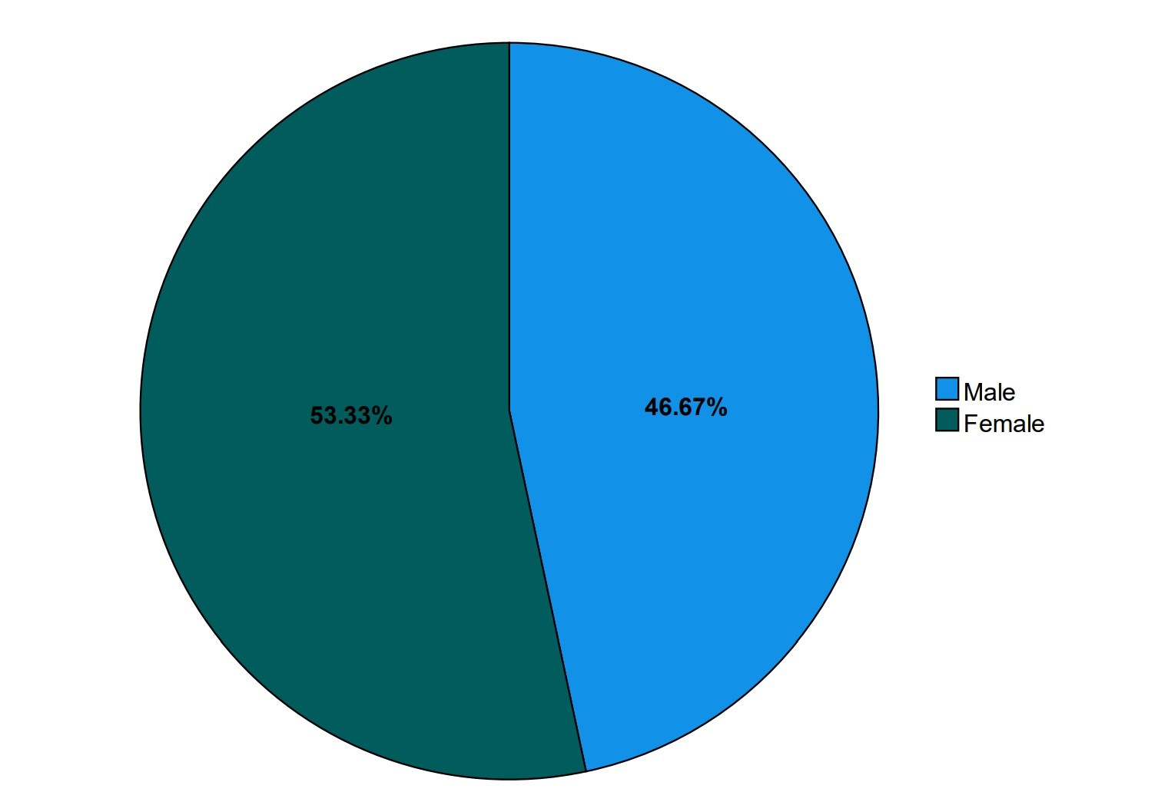

figure 4. 1: Analysis of respondent patients/ caregivers

From the above figure, it shows the domination of female respondents among the patients and caregivers were more than the male respondents.

**Analysis of the new patients who were admitted and those that were re-attendees in the hospital basing on different age groups in the months of November 2022, December 2022 and January 2023**.

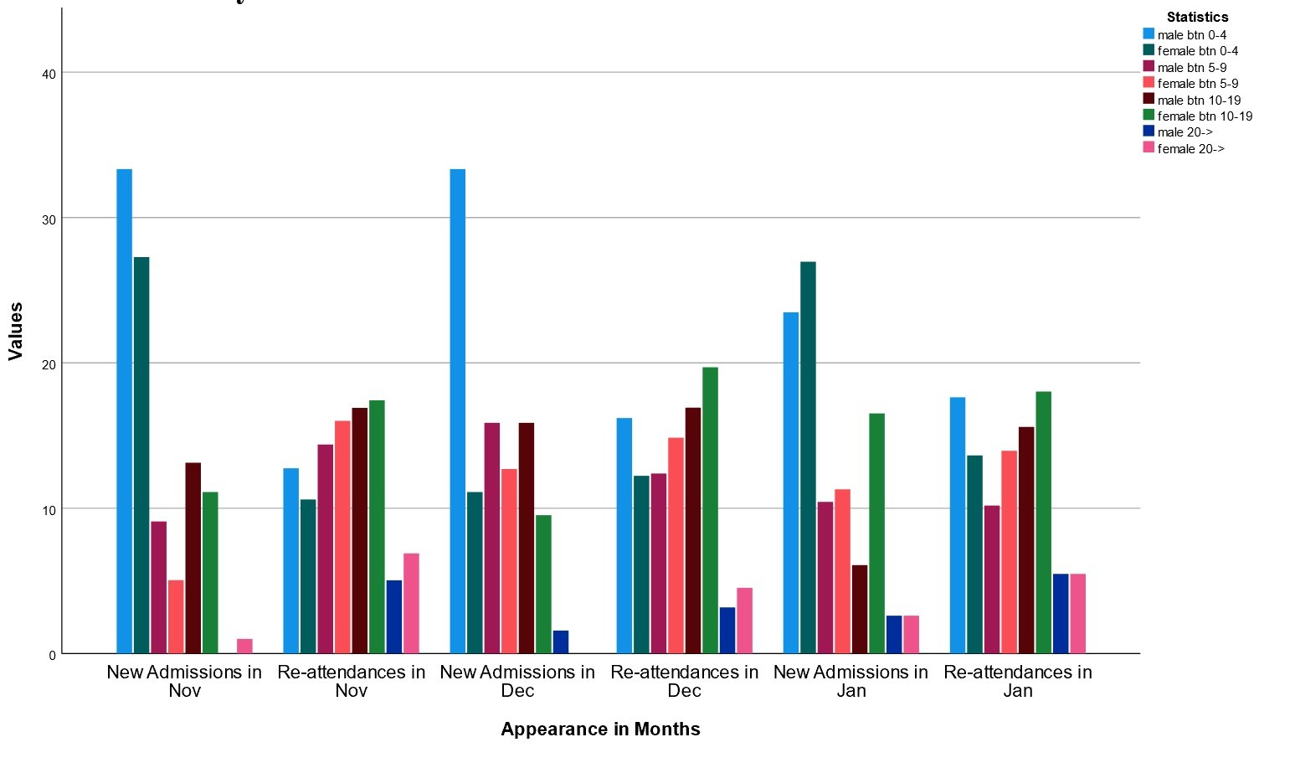

figure 4. 2: Analysis of respondent monthly attendance and re-attendance

The figure above shows the male patient in the age group of 0-4 years being the most newly admitted patients followed by the female patients in the same age group. We also observed that in all the three months, the male and female patients in the age group of 20 who returned to the hospital were very few while the re-attendance of the rest of the age groups was relatively constant and high.

**Analysis of how often the patient/caregiver respondents visit the doctors.**

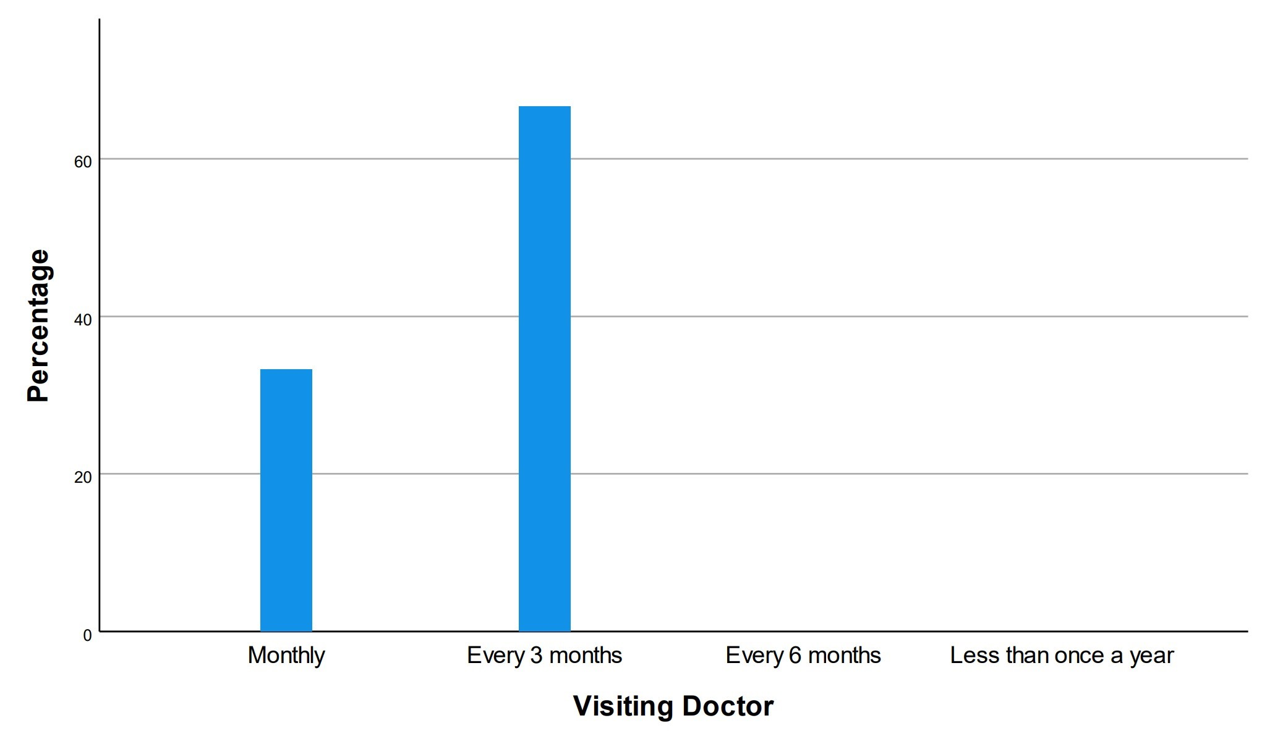

figure 4. 3: Analysis of how often respondents visit the doctors

The figure above shows that most patients and caregivers respondents visit the doctors after three months.

**Analysis on how patients/caregivers respondents currently communicate with the doctors.**

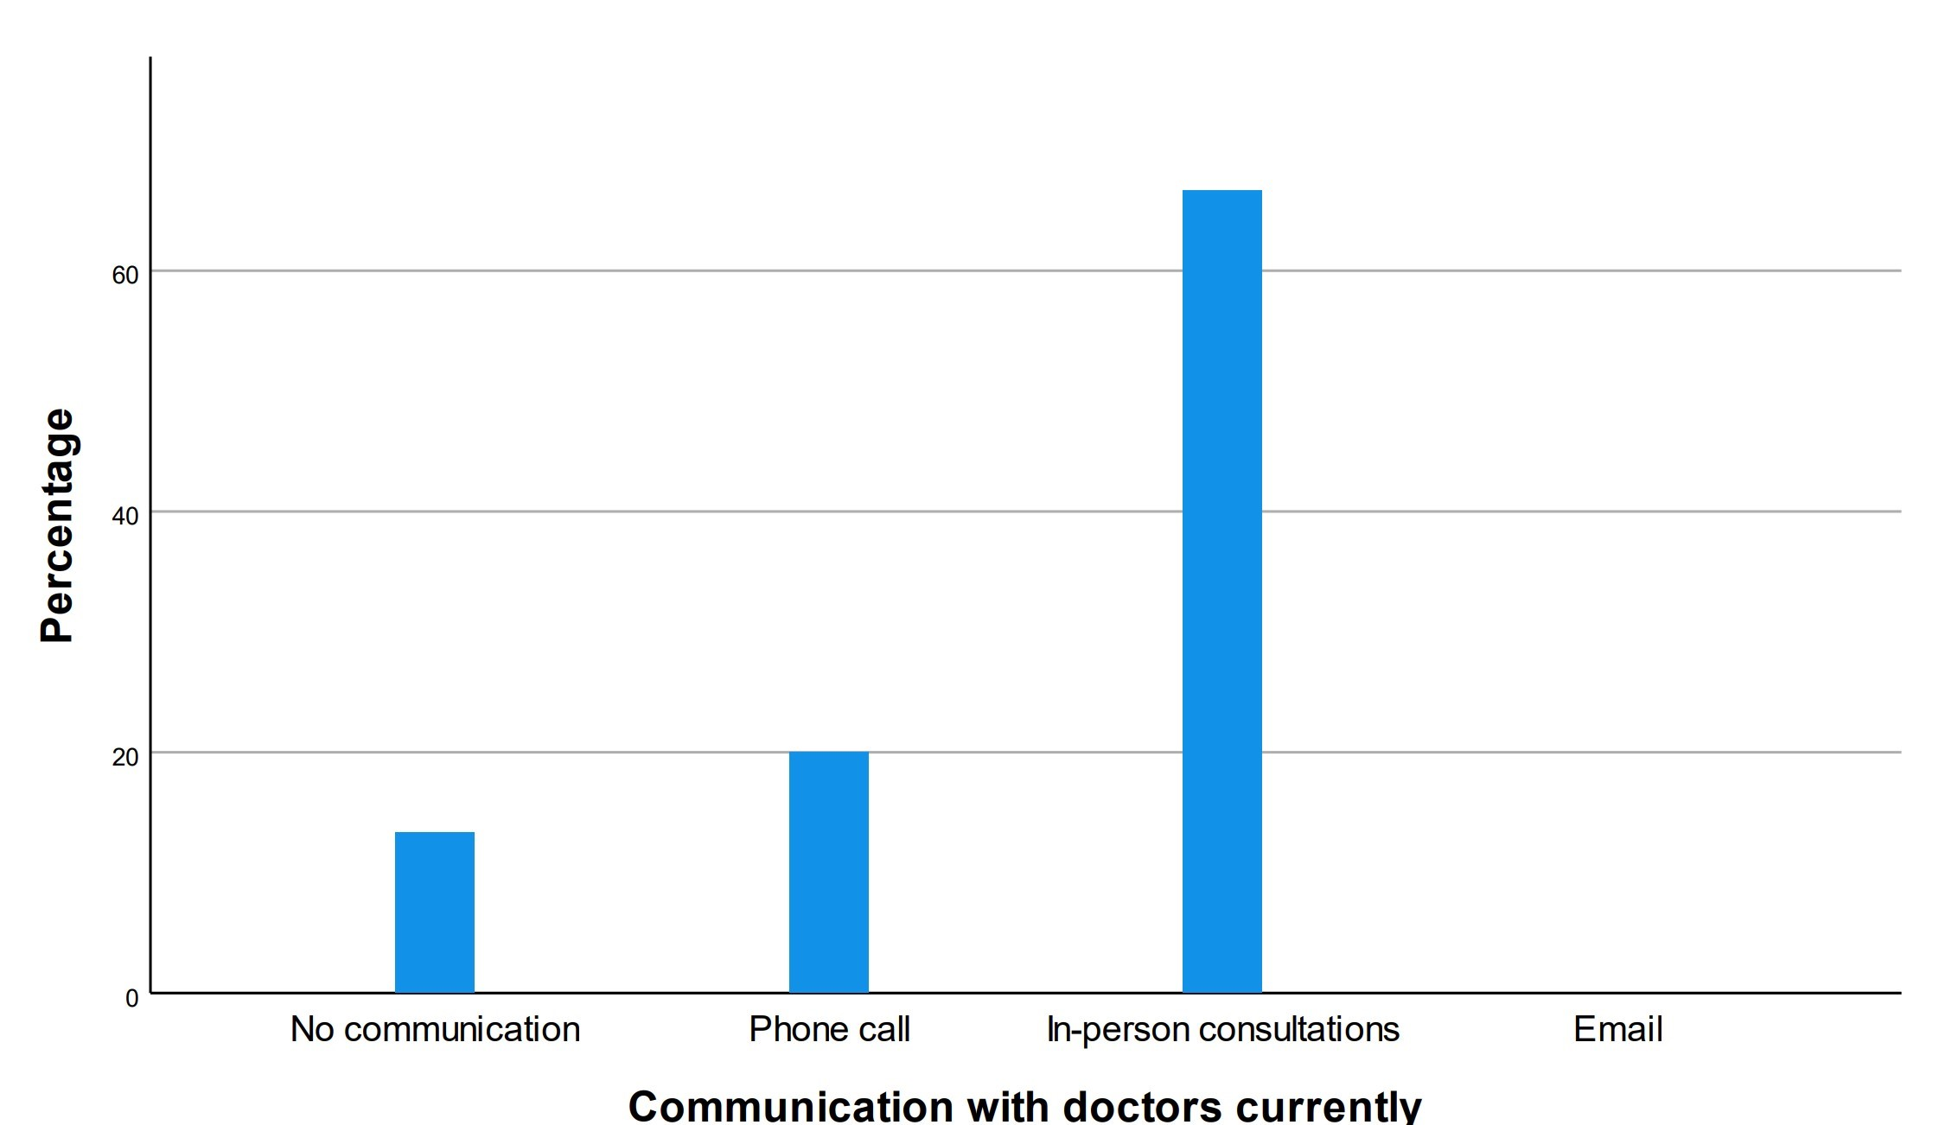

figure 4. 4: Analysis on how respondents currently communicate with the doctors

**Analysis on the system features required by the patient/caregiver respondents.**

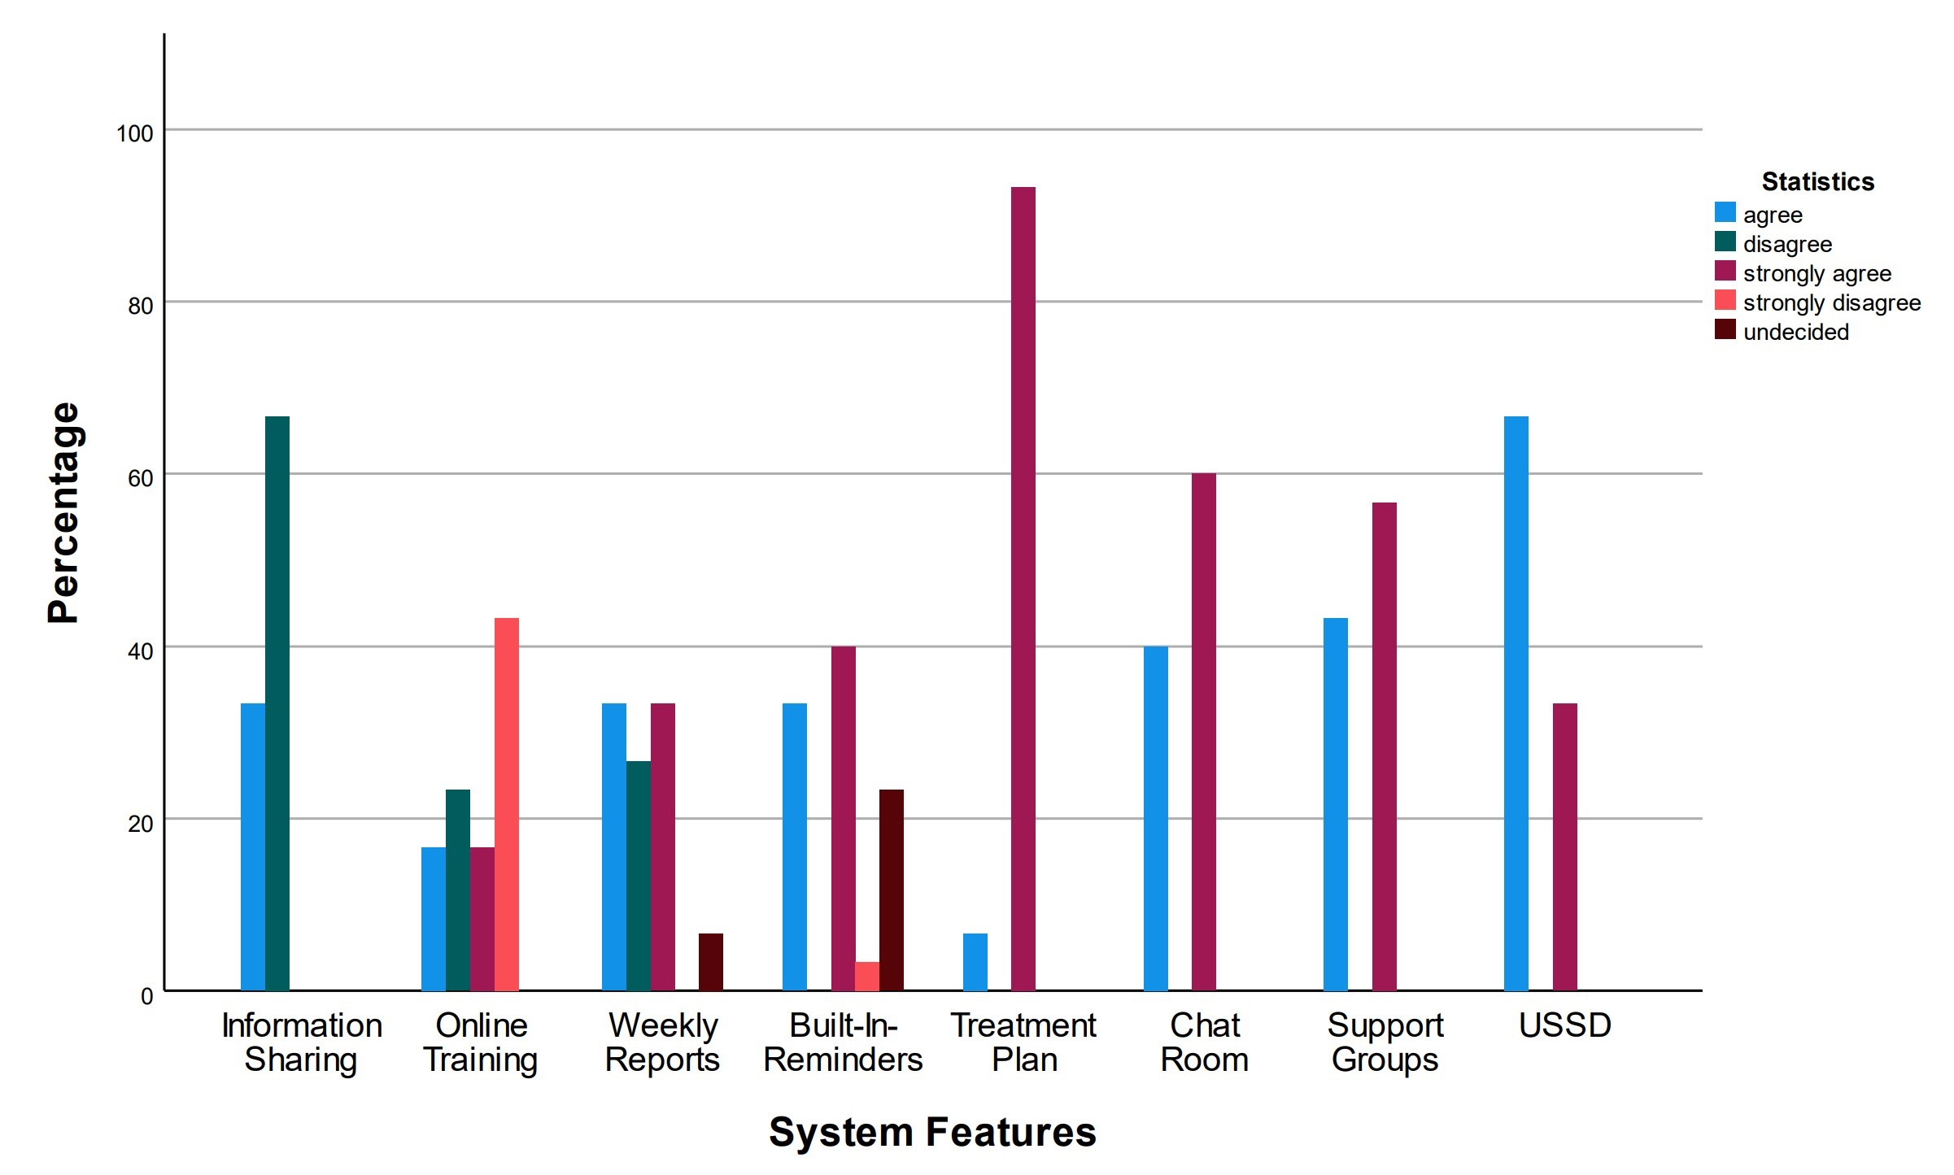

figure 4. 5: Analysis on the system features required by the respondents

The figure above shows that the respondent patients/caregivers don’t use any system to manage the disease.

**Analysis of how many patient/caregiver have ever used a system for management of the disease.**

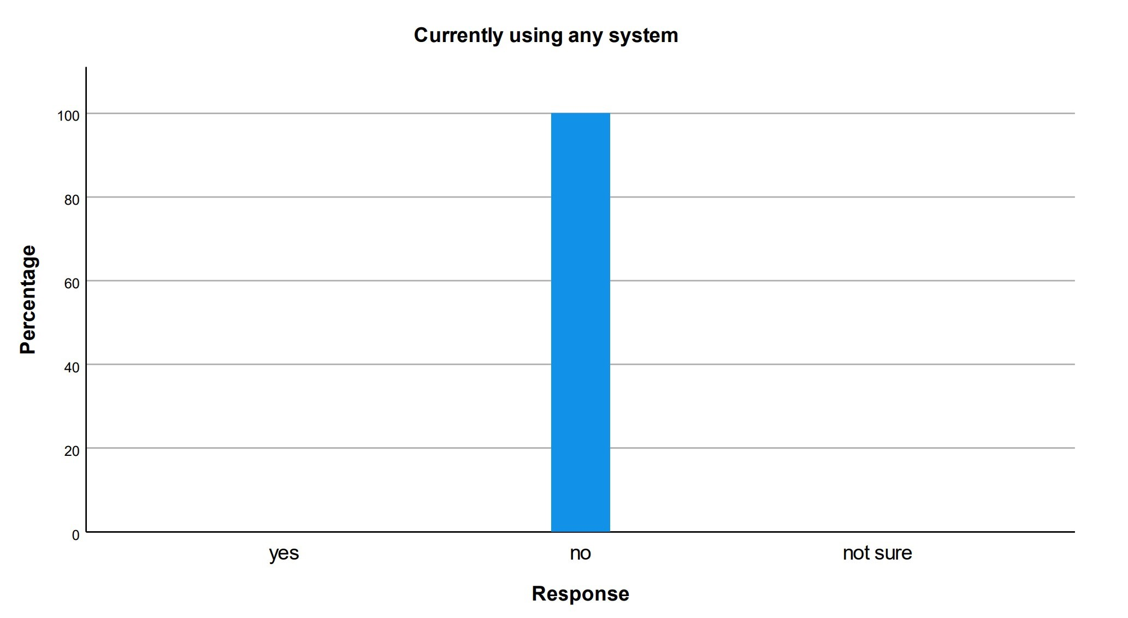

figure 4. 6: Analysis showing use of systems in sickle cell management

From the above figure, it is observed that most of the patient/caregiver respondents agreed and strongly agreed with most of the features of the sickle cell disease management system. Some respondents strongly disagreed with the online training feature and some were indecisive about the weekly reports and built-in-reminders features.

**Analysis on how the respondent doctor currently communicate with the patients/caregivers.**

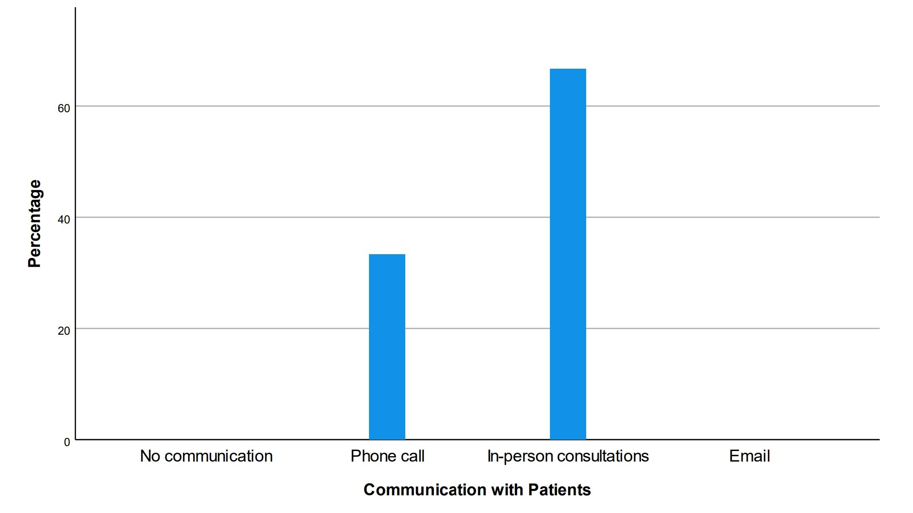

figure 4. 7: Analysis on how doctors communicate with the patients / caregivers

In the figure above, it is observed that doctors mostly communicate with the patients/caregivers during the in-person consultations and that’s mostly when the patient of caregiver goes back to the hospital after the out-patient care period.

**Analysis on how often Doctors see or receive patients/caregivers.**

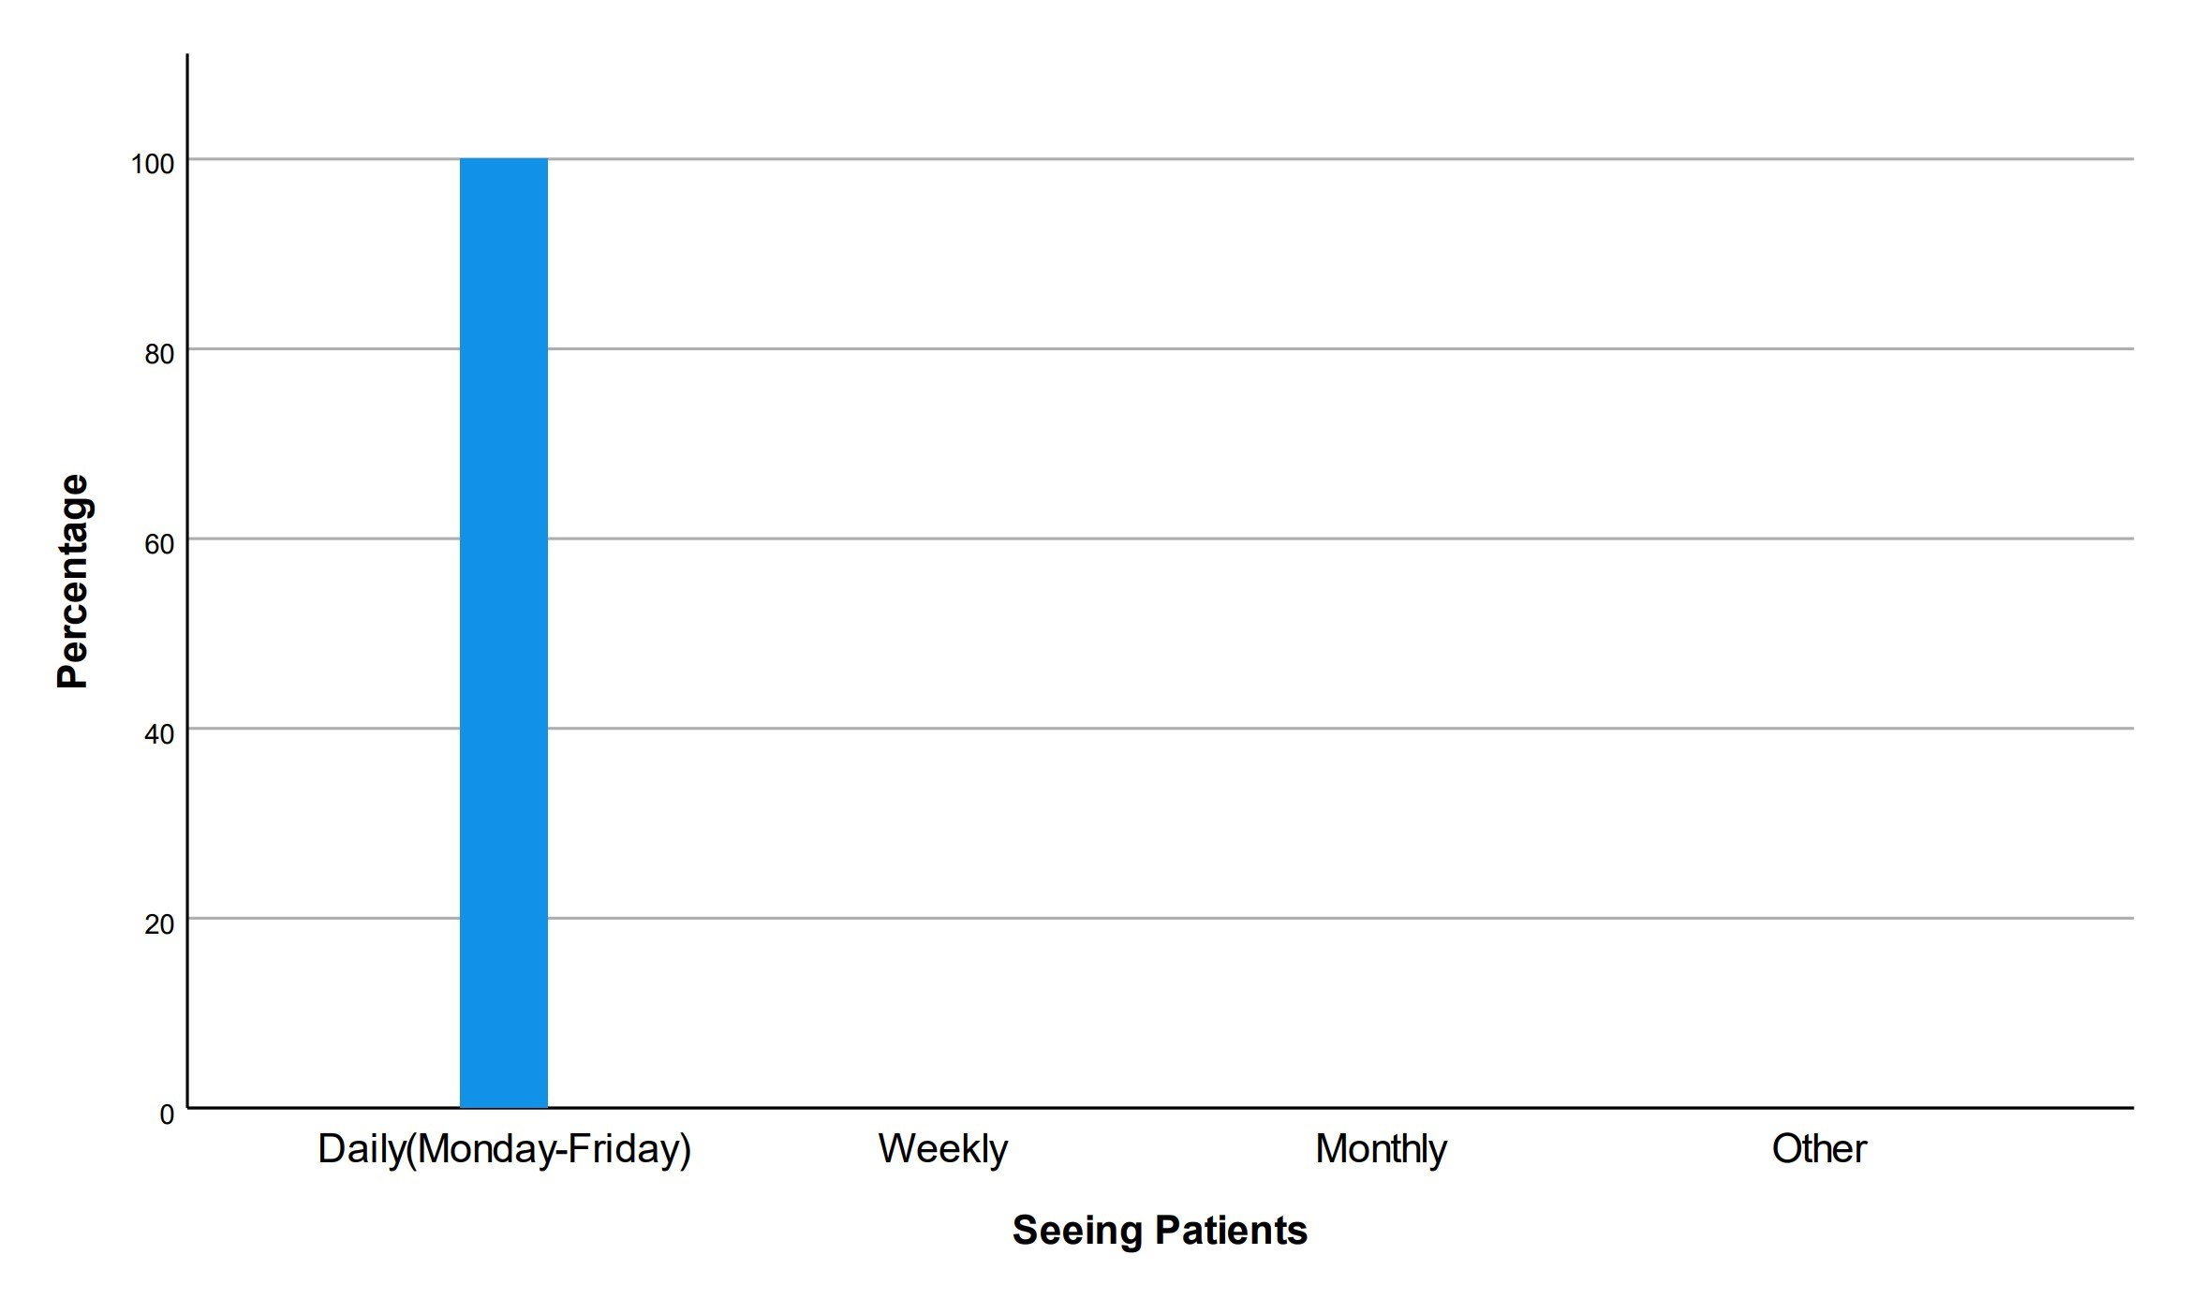

figure 4. 8: Analysis on how doctors see or receive patients/ caregivers

In the figure above, it was observed that doctors receive patients/caregivers daily from Monday to Friday which are their working hours.

### **4.3.3 Requirements Analysis**

In the previous section, data analysis was done. In this section, user, functional, non-functional and system requirements were derived from the analyzed data.

## 4.4 System User Requirements

There are three groups of users:

1. **System Administrators:** They have a higher understanding of how the system works. System administrators also have more privileges compared to other users.
2. **Project Managers**: They have privileges that allow them to update project’s progress such that the users of the system know what’s on ground in real time.
3. **Registered Users**: They are categorized into patients, caregivers and doctors.

## 4.5 Functional and non-Functional Requirements

### **4.5.1 Functional Requirements**

Functional requirements are the specific features and functionalities that a software system must possess to fulfill the needs of its users. In the context of a healthcare information system, the following are some functional requirements that the system should have:

User authentication and authorization: This functional requirement involves providing a secure login system that allows only authorized users to access the system. User authentication should be based on strong passwords. Authorization refers to controlling what actions users are allowed to perform within the system, based on their roles and privileges.

Patient management: This functional requirement involves managing patient-related information such as appointment scheduling, patient registration, and patient record management. Appointment scheduling involves managing the availability of healthcare providers and scheduling appointments for patients. Patient registration involves creating and maintaining patient profiles, including demographic information, medical history. Patient record management involves managing patient health records.

Management of medication and treatment plans: This functional requirement involves managing medication prescriptions and treatment plans for patients. Medication management involves tracking medication prescriptions, dispensing medications, and monitoring patient adherence. Treatment plan management involves creating and managing treatment plans for patients, including prescriptions, follow-up appointments, and other treatments.

Reporting and analytics: This functional requirement involves generating reports and analyzing data to identify trends and patterns in patient health data. This includes the ability to generate reports on patient health outcomes, treatment outcomes, and other metrics that can help healthcare providers improve patient care and outcomes.

Clinical Decision Support: This functional requirement involves providing decision making support for healthcare providers. This includes providing alerts and reminders for appointments, medications, and tests, and providing guidance on treatment options based on patient data.

Security and Privacy: This functional requirement involves ensuring the security and privacy of patient data. This includes implementing data encryption, access controls, and other measures to protect patient data from unauthorized access or disclosure

In summary, the functional requirements of a healthcare information system should provide a secure login system, manage patient information and health records, manage medication and treatment plans, store and manage lab test results and other diagnostic reports, and provide reporting and analytics capabilities.

### **4.5.2 Non-functional Requirements**

Non-functional requirements define the overall characteristics of a software system that are not directly related to its functionality but are critical for the system’s success. In the context of a healthcare information system, the following are some non-functional requirements that the system should have:

System security: This non-functional requirement involves ensuring that the healthcare information system is secure and that patient data is protected from unauthorized access or disclosure. The system should use encryption to protect data at rest and in transit, implement access controls to ensure that only authorized users can access patient data, and provide audit trails to track access to patient data.

System scalability: This non-functional requirement involves ensuring that the healthcare information system can scale up or down to meet changing demands. The system should be able to handle a large volume of users and patient data without compromising performance or availability. Scalability is critical for ensuring that the system can accommodate future growth in the number of users and patient data.

System performance: This non-functional requirement involves ensuring that the healthcare information system can perform effectively and efficiently. The system should be able to process user requests quickly and provide fast access to patient data. Performance is critical for ensuring that healthcare providers can access patient data quickly and make timely decisions about patient care.

System availability and reliability: This non-functional requirement involves ensuring that the healthcare information system is available and reliable. The system should be up and running 24/7 and be able to recover quickly from any downtime or system failures. Reliability is critical for ensuring that healthcare providers can access patient data when they need it and that patient care is not compromised due to system failures.

User interface design: This non-functional requirement involves designing a user-friendly and intuitive interface that makes it easy for healthcare providers to access and use the system.

Compatibility and interoperability: This non-functional requirement involves ensuring that the healthcare information system can integrate with other systems, such as EHRs and billing systems.

Compliance: This non-functional requirement involves ensuring that the healthcare information system complies with relevant regulations and standards, such as HIPAA and GDPR.

**Software Requirements**

Compatibility is a requirement to ensure that our system has the ability to run and perform required tasks properly. The table below points out the minimum requirements for the system.

|  |  |
| --- | --- |
| **Software** | **Minimum System Requirements** |
| Browser | Google Chrome, Mozilla fire Fox, Opera mini, Edge, Explorer |
| Database | Firebase (Firestore) |
| Operating System | All windows operating systems and android operating systems. |
| Security | Firebase Authentication |

Table 4. 2: Software requirements of the system

**Hardware requirements**

The system required performing its specific tasks properly on hardware facilities. We carried out research in various areas using different kinds of hardware facilities such as smart phones and desktops to ascertain the right hardware for optimal system performance.

|  |  |  |  |
| --- | --- | --- | --- |
| Hardware | Minimum System Requirements | | |
| RAM | 2GB |  |  |
| Disk space | 10GB |  |  |

Table 4. 3: Hardware requirements of the system

## 4.6 High level Architecture of the developed system

**Mobile Phone Architecture**

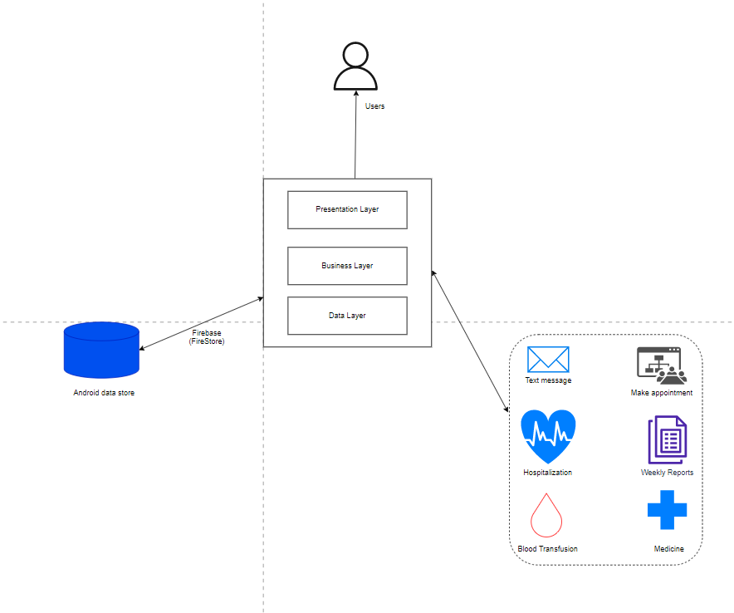

figure 4. 9: Mobile phone architecture

**Web app architecture**.

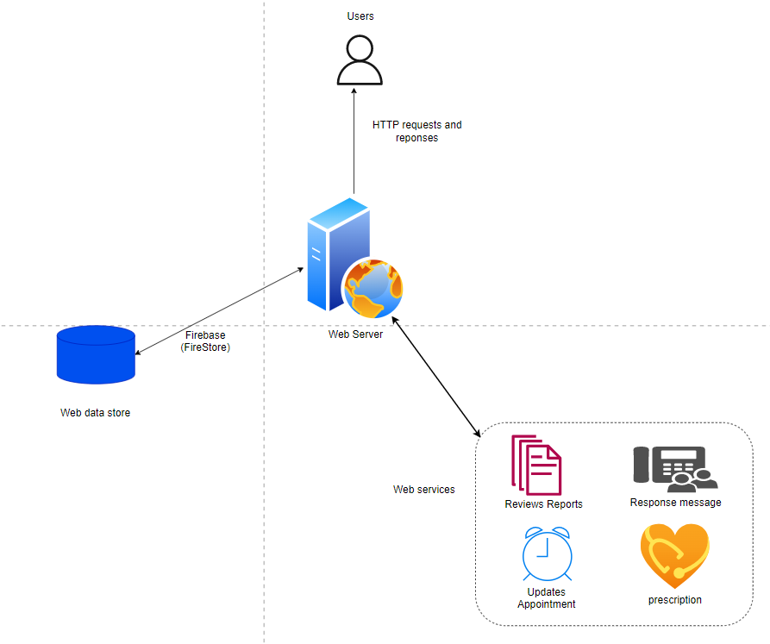

figure 4. 10: Web app architecture

**Users:** Make requests to the server and receive responses.

**Database:** For data storage.

**Web Services**: Interaction with other applications.

**USSD:** For offline access.

**Web Server**: Hosts the applications’ various layers, which include;

**Presentation layer:** Users interact with the application through the presentation layer (Web browser).

**Application layer**: Implements the business logic. Interacts with the data layer processes requests and responses.

**Data layer:** processes requests and responses with help of the other layers.

## 4.7 The Flow Chart of the developed system

A flow chart is a graphical representation of a computer algorithm, visualizing the design of a system showing all the steps leading to a solution of a given task. It involves initial node, control flows, actions, processes, decision node.

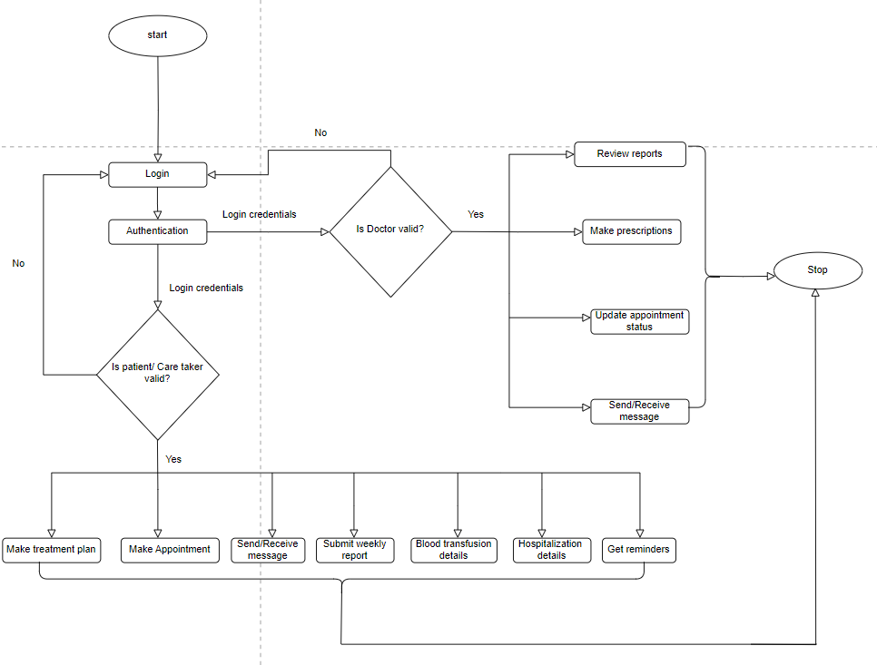

figure 4. 11: Flow Chart Diagram

## 4.8 Context Diagram

Process modelling aims at representing the processes, which capture, manipulate, store and distribute data. We used a context diagram and a level 1 data flow diagram DFD to illustrate the activities.

A context diagram shows how different actors interact with the system. It is a simple data flow diagram that shows an abstract flow of information between the system and various entities.

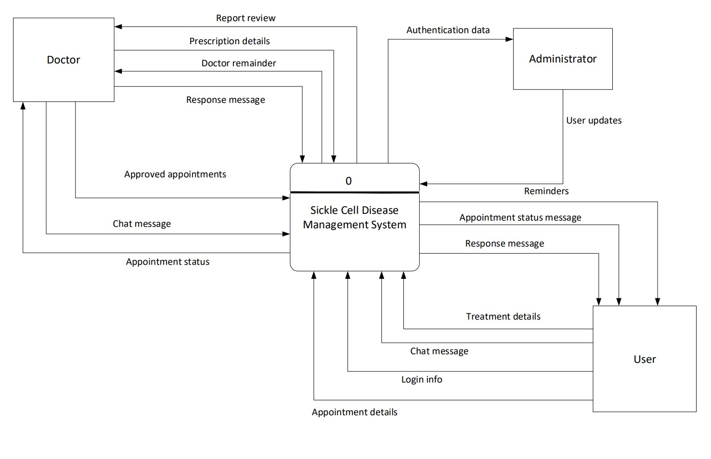

figure 4. 12: Context Diagram

### **4.8.1 Level 1 Data Flow Diagram**

Level 1 DFD is more detailed than a context diagram. It shows a detailed flow of information between the system processes, data stores and entities. The entities in the first diagram remain constant but the diagram is expanded into close-ups showing data stores and flows.



figure 4. 13: Level 1 Data Flow Diagram

The following are the symbols used process modelling.

|  |  |  |
| --- | --- | --- |
| **Symbols** | **Name** | **Description** |
|  | Process | It shows the different processes in the data flow. |
| |  |  | | --- | --- | |  |  | | Data store | It holds and stores data that has been collected |
|  | Entity | It shows the different entities of the system |
|  | Repeated entity | It shows a recurrent entity |
|  | Data flow | It shows the different processes in the data flow. It shows the direction to which different information is moving |

Table 4. 4: Process modelling Symbols and their Descriptions

**Data Dictionary for the DFD**

The data dictionary contains descriptions of processes, data stores and external entities identified during process modelling.

|  |  |
| --- | --- |
| **Entity** | **Description** |
| User | * The user i.e. patient/caretaker of the system can perform the following tasks. * Registers to create an account. * Log on the system. * Interact with the system through making appointments, interacting with fellows through chat messages, creating their own treatment plans with reminders, submit weekly reports, adding prescription details, adding any blood transfusion details and adding hospitalization details. |
| Administrator | An administrator manages and performs the following tasks:   * Log on the system * Upgrades users i.e., doctors, patients/ caregivers * Deletes users * Degrades users * Manages security and backs up system data |
| Doctor | * A doctor performs the following tasks, * Logs on to the system * Updates appointment status * Reviews submitted weekly reports * Responds to patient/caretaker questions through chats Sends confirmation message to the patient/caretaker about appointment. * Makes medication prescriptions for patients. |

Table 4. 5: Entities and their Descriptions

|  |  |
| --- | --- |
| **Process** | **Description** |
| Login | Enables a system user like a doctor, a patient/caretaker to log into the system. |
| Verify user | Ensures user’s details much the ones in the database already |
| Authenticate administrator | Ensures the administrator is he or she claims to be. |
| Authenticate doctor | Ensures the doctor is he or she claims to be. |
| Make appointment | Enables users to schedule appointments with the doctors who also confirm these appointments. |
| Prescription | Doctor makes prescription for patient as her or she is given the medicine and the patient can add medicine prescription in case medicine is gotten out of the hospital. |
| Write message | Enables users to write messages to fellows and also respond to others messages. |
| Blood Transfusion | Add any blood Transfusion details. |
| Hospitalization | Add any hospitalization during the Out-patient care period |

Table 4. 6: Processes and their Descriptions

|  |  |
| --- | --- |
| **Data Stores** | **Description** |
| User | Stores login credentials for all system users |
| Reports | Stores information about the weekly reports |
| Treatment | Stores information about treatment plans made by patients/caregivers |
| Appointment | Stores information about the appointments scheduled |
| Chat | Stores information about the messages exchanged between users while using the system. |
| Transfusion | Stores blood transfusion details. |
| Hospitalization | Stoes hospitalization details. |

Table 4. 7: Data stores and their Descriptions

## 4.9 The Use Case Diagram

The Sickle Cell Management System is a comprehensive solution designed to facilitate the efficient management of patients with sickle cell disease. This Use Case Diagram showcases the key functionalities and interactions within the system. It illustrates the roles and actions of various users, including patients, doctors, and system administrators. The diagram provides a visual representation of how the system supports appointment scheduling, patient-doctor communication, medical prescription, weekly reporting, and system administration. It serves as a blueprint for understanding the system’s use cases and their relationships.

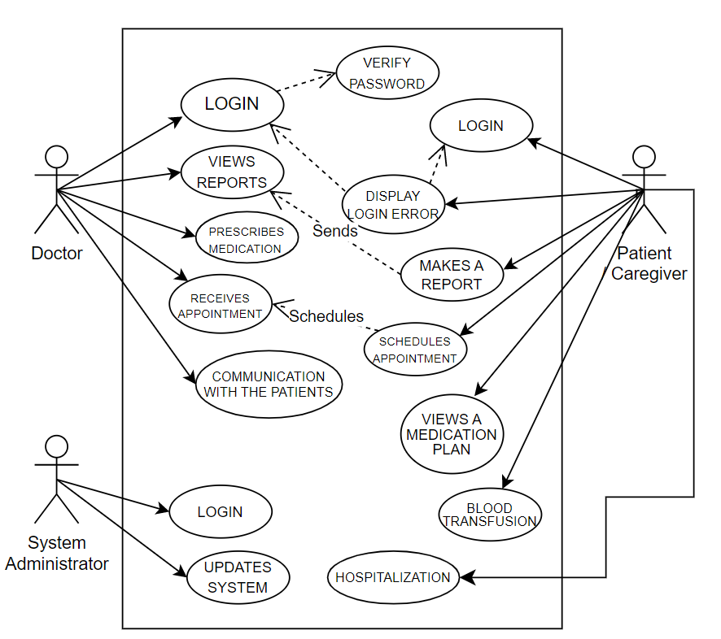

figure 4. 14: Use Case Diagram

## 4.10 Enhanced Entity Relationship Diagram (EERD)

This involves data modeling which is the process of creating a visual representation of either a whole information system or parts of it to communicate connections between data points and structures. The goal is to illustrate the types of data used and stored within the system, the relationships among these data types, the ways the data can be grouped and organized and its formats and attributes. It involves identifying the system requirements and deriving entities and their associated cardinalities and their meanings.

1. **Relationship between the Doctor and Appointment**

A Doctor can check for a minimum of one Appointment and a maximum of many Appointments while each appointment can be viewed by a minimum of one Doctor and a maximum of one Doctor. This is a one-to-many Relationship.

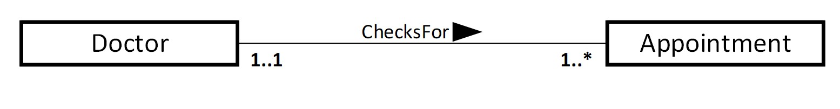

1. **Relationship between the Doctor and Prescription.**

A Doctor makes a minimum of one prescription of medicine for the patient and a maximum of many prescriptions of different kinds of medicine to the patient. The prescription can be made by a minimum of one Doctor and a maximum of one Doctor. This is a one-to-many Relationship.



1. **Relationship between the Doctor and Patient / Caregiver.**

A Doctor receives a minimum of many Patients / Caregivers and a maximum of many Patients / Caregivers while a patient or caregiver can be received by a minimum of one Doctor and a maximum of one Doctor. This is a one-to-many Relationship.

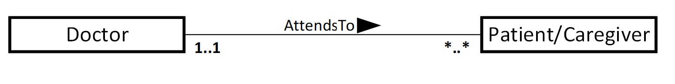

1. **Relationship between the Doctor and Weekly reports**

A Doctor reviews a minimum of one weekly report from the patient and a maximum ofmany Weekly reports. The weekly reports can be reviewed by a minimum of one Doctor and a maximum of one Doctor. This is a one-to-many Relationship.

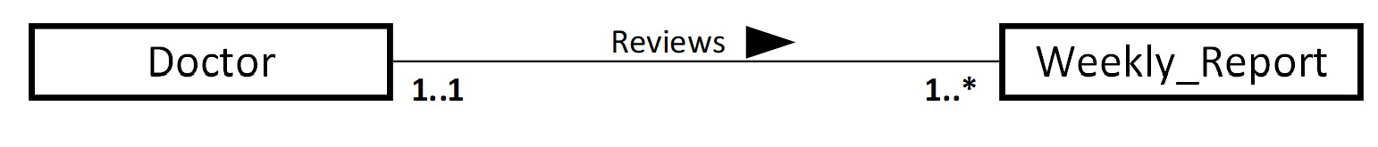

1. **Relationship between the Doctor and Prescription**

A Doctor makes a minimum of one prescription of medicine for the patient and a maximum of many prescriptions of different kinds of medicine to the patient. The prescription can be made by a minimum of one Doctor and a maximum of one Doctor. This is a one-to-many Relationship.

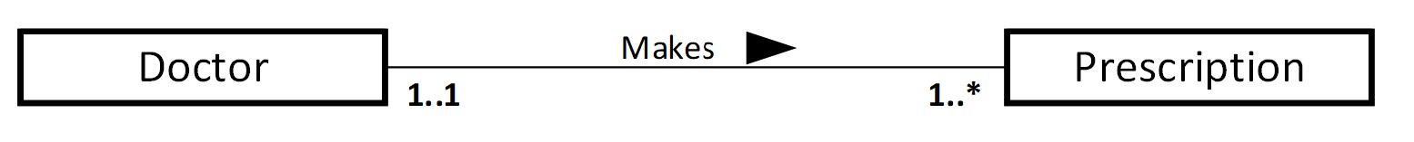

1. **Relationship between the Patient / Caregiver and Appointment** A Patient or Caregiver schedules a minimum of one appointment and a maximum of many Appointments while an Appointment can be scheduled by one and only one Patient or Caregiver. This is a one-to-many Relationship.

newline

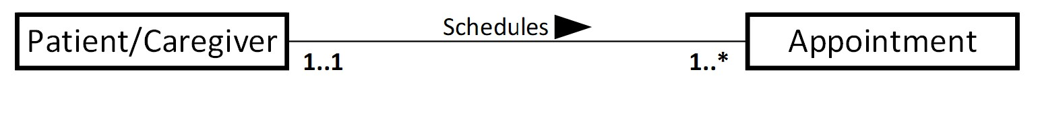

1. **Relationship between the Patient / Caregiver and Weakly report.** A patient/caregiver formulates a minimum of one weekly report and a maximum of many Weekly reports. A weekly report can be formulated one and only one patient/caregiver. This is a one-to-many Relationship.

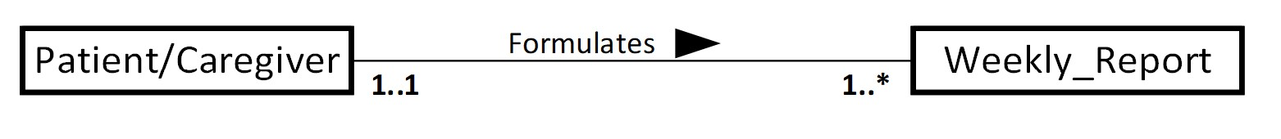

1. **Relationship between the Patient / Caregiver and the Support Group.** A Patient or Caregiver assesses a minimum of one Support Group information and a maximum of many Support Group information while a Supported Group information can be assessed by a one and only one Patient or Caregiver. This is a one-to-many Relationship

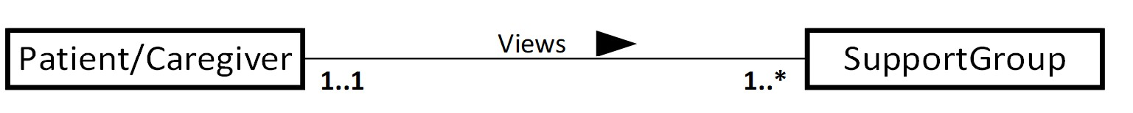

1. **Relationship between the User and Sent Message.**

A User can send zero or many messages and a message can be sent by one and only one user. Hence making this a one-to-many relationship. This is a one-to-many relationship.

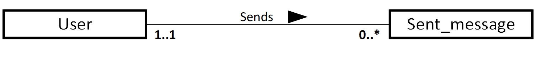

10. **Relationship between the User and Received Message.**

A User can send zero or many messages and a message can be sent by one and only one user. Hence making this a one-to-many relationship. This is a one-to-many Relationship.





figure 4. 15: Enhanced Entity Relationship Diagram

**Database Design**

Below is the database design.

|  |  |  |  |
| --- | --- | --- | --- |
| Table | Attribute | Key | Null |
| Doctor | userId | Primary key | Not |
| name | None | Not |
| phone | None | Not |
| email | None | Not |
| password | None | Not |
| profilePic | None | Null |
| status | None | Not |
| address | None | Not |
| doctorRegNo | None | Not |
| Patient | userId | Primary key | Not |
| name | None | Not |
| phone | None | Not |
| email | None | Not |
| password | None | Not |
| profilePic | None | Null |
| status | None | Not |
| address | None | Not |
| patientNo | None | Not |
| Admin | userId | Primary key | Not |
| name | None | Not |
| phone | None | Not |
| email | None | Not |
| password | None | Not |
| profilePic | None | Null |
| status | None | Not |
| address | None | Not |
| adminNo | None | Not |
| Sent_message | messageId | Primary key | Not |
| messageBody | None | Not |
| timeSent | None | Not |
| userId | Foreign key | Not |
| Received_message | messageId | Primary key | Not |
| messageBody | None | Not |
| timeReceived | None | Not |
| userId | Foreign key | Not |
| Appointment | appointmentId | Primary key | Not |
| appointmentDate | None | Not |
| appointmentTime | None | Not |
| doctorRegNo | Foreign key | Not |
| patientNo | Foreign key | Not |
| Weekly_Report | reportNumber | Primary key | Not |
| date | None | Not |
| time | None | Not |
| patientNo | Foreign key | Not |
| doctorRegNo | Foreign key | Not |
| Support_Group | name | Primary key | Not |
| Blood_Transfusion | Transfusion_id | Primary key | Not |
|  | bloodTransfusionDate | None | Not |
|  | Duration | None | Not |
|  | Hb_before_transfusion | None | Not |
|  | Hb_after_transfusion | None | Not |
|  | notes | None | Not |
| Hospitalization | Hospitalization_Id | Primary key | Not |
|  | AdmissionDate | None | Not |
|  | dischargeDate | None | Not |
|  | Complaint | None | Not |
|  | Treatment | None | Not |
| Prescription | medicineId | Primary key | Not |
|  | medicineName | None | Not |
|  | medicineType | None | Not |
|  | medicineStrength | None | Not |
|  | startDate | None | Not |
|  | medicineDuration | None | Not |
|  | medicineInstruction | None | Not |
|  | takingMedicine | None | Not |
|  | doctorRegNo | Foreign Key | Not |
|  | patientNo | Foreign Key | Not |

Table 4. 8: Database Design

## 4.11 Dynamic Modeling

### **4.11.1 Activity Diagrams**

The activity diagram presented below outlines the essential workflow of a Sickle Cell Management System. This system aims to provide efficient management and support for patients with sickle cell disease. By visualizing the key activities involved in the system, this diagram offers a clear overview of how patients schedule appointments, communicate with doctors, submit reports, receive recommendations, and benefit from medication plans. With the integration of support groups and the continuous updating of system settings by the administrator, this comprehensive solution strives to enhance the overall care and well-being of individuals affected by sickle cell disease.

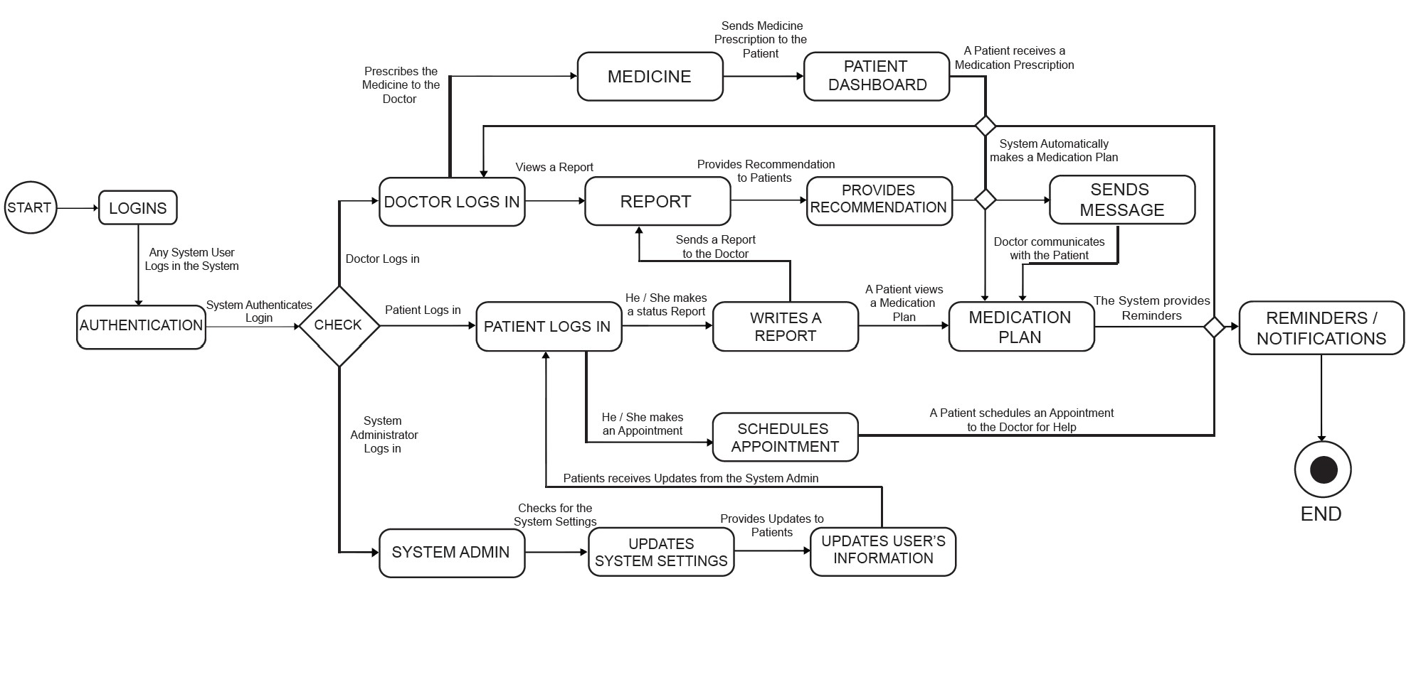

figure 4. 16: Activity Diagram

### **4.11.2 Sequence Diagrams**

The Sickle Cell Management System is designed to streamline and enhance the process of managing patients with sickle cell disease. This system utilizes a sequence diagram to illustrate the various interactions and steps involved in effectively managing the condition. From scheduling appointments and receiving doctor’s recommendations to medication plans and communication between doctors and patients, the sequence diagram provides a visual representation of the comprehensive workflow within the system. By implementing this system, healthcare professionals can ensure efficient and personalized care for individuals with sickle cell disease.

Registration Process

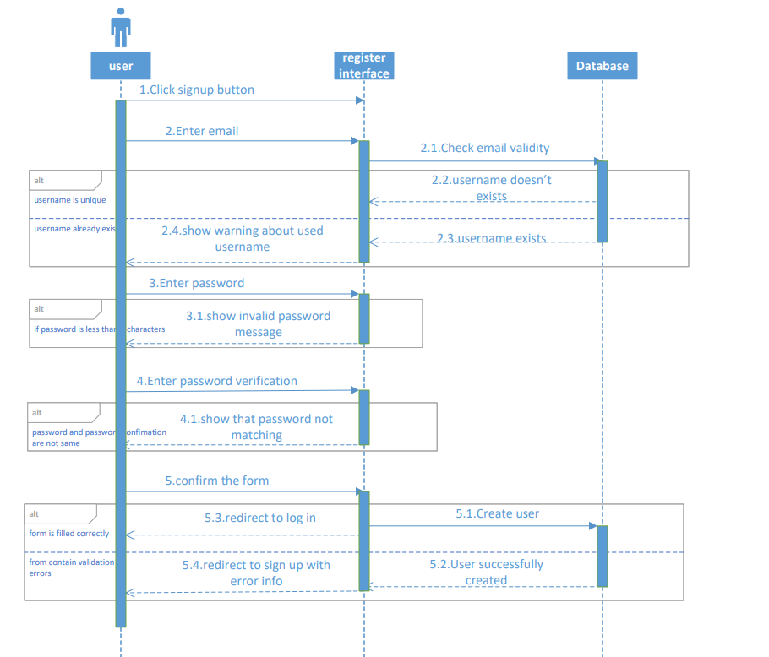

figure 4. 17: Registration process

Login process

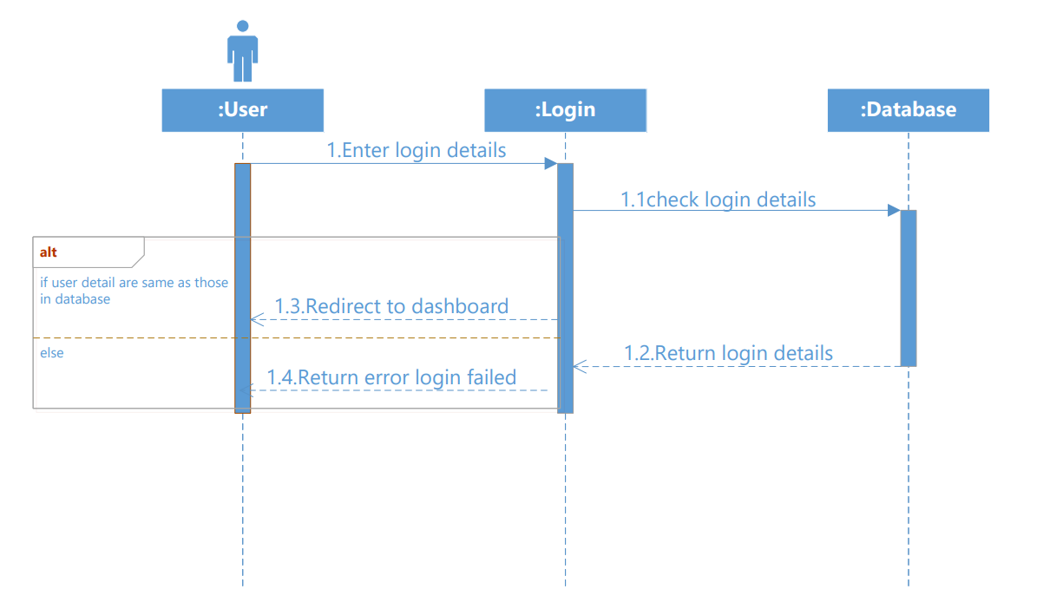

figure 4. 18: Login process

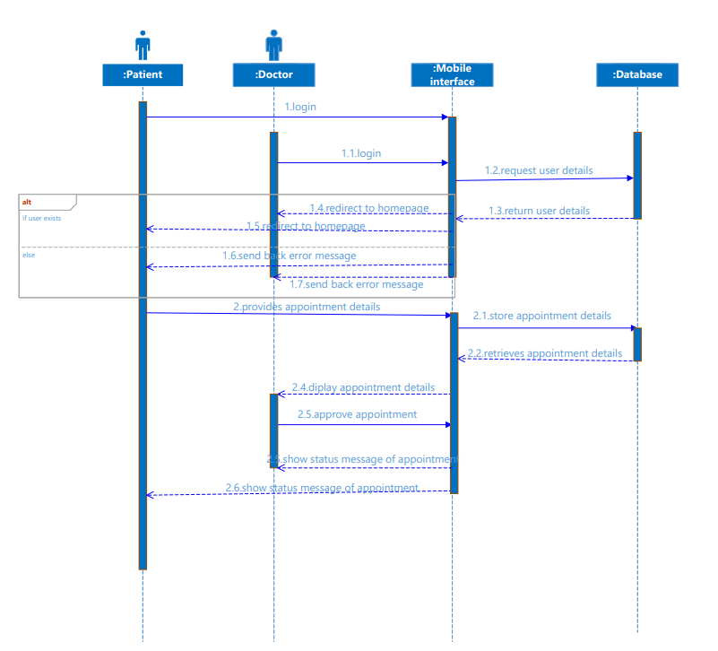Appointment process

figure 4. 19: Appointment Process

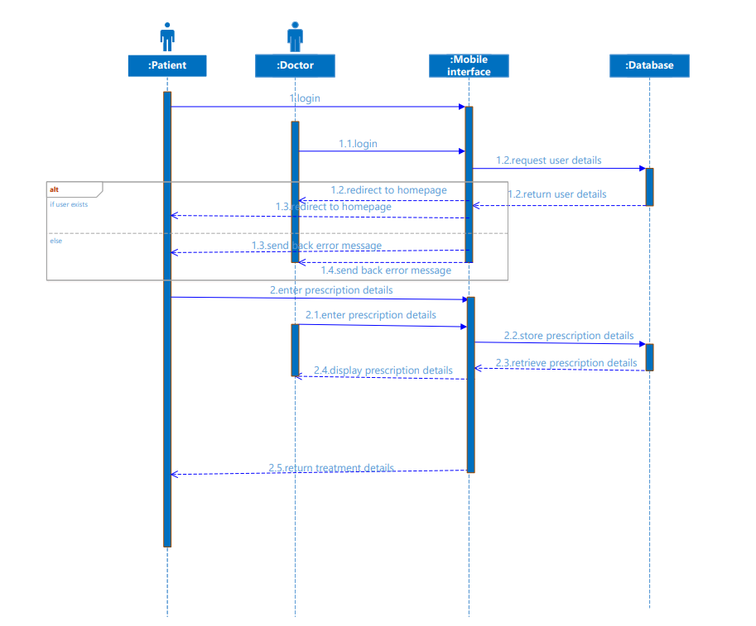Prescription process

Figure 4.2 0: Prescription Process

Messaging

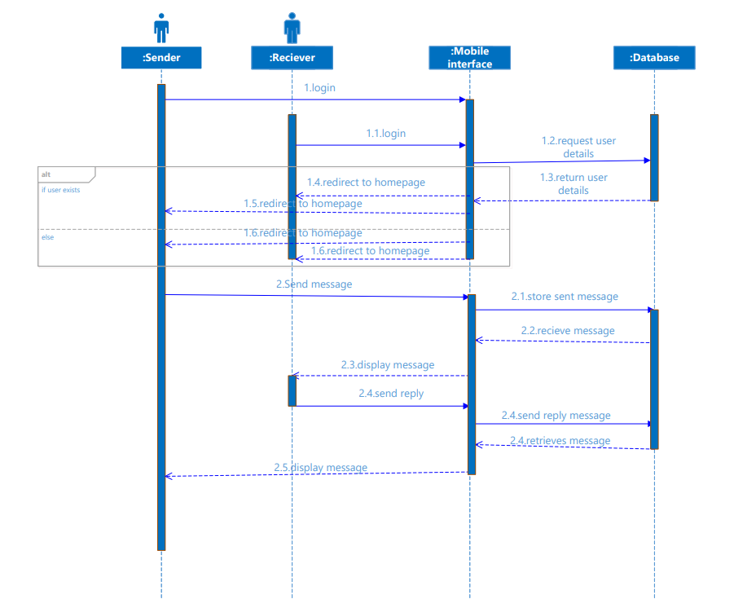

Figure 4.2 1: Messaging process

### **4.11.3 Collaboration Diagrams**

The Collaboration Diagram for a sickle cell management system represents the interactions and relationships between different entities involved in the system. This diagram visualizes how patients, doctors, and the system administrator collaborate to facilitate effective management of sickle cell disease. By illustrating the flow of communication, appointment scheduling, report analysis, prescription management, and system updates, the Collaboration Diagram provides a comprehensive overview of the interactions within the system. This diagram serves as a valuable tool in understanding the coordination and cooperation required to ensure efficient and personalized care for individuals with sickle cell disease.

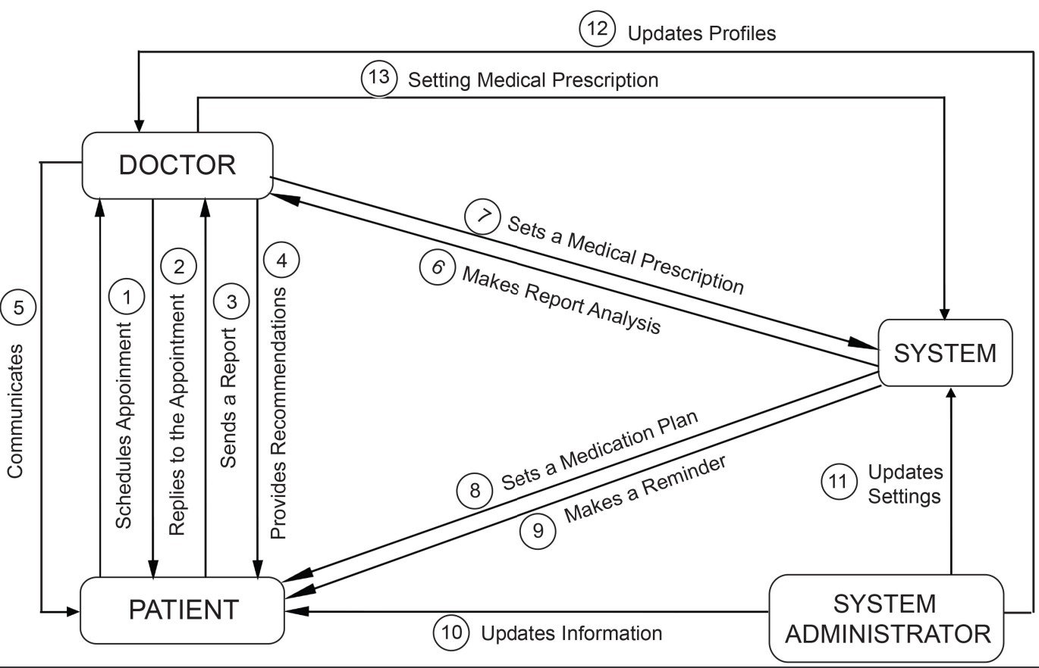

Figure 4.2 2: Collaboration Diagram

### **4.11.4 State chart Diagrams**

The state chart diagram for a sickle cell management system represents the various states and transitions involved in managing and monitoring patients with sickle cell disease. This diagram provides a visual representation of the system’s behavior, illustrating how it responds to different events and conditions related to the patients’ health and treatment. By capturing the key states and their transitions, the state chart diagram helps in understanding the flow of activities and decision-making within the sickle cell management system. It serves as a valuable tool for designing and improving the system, ensuring efficient and effective management of patients with sickle cell disease.

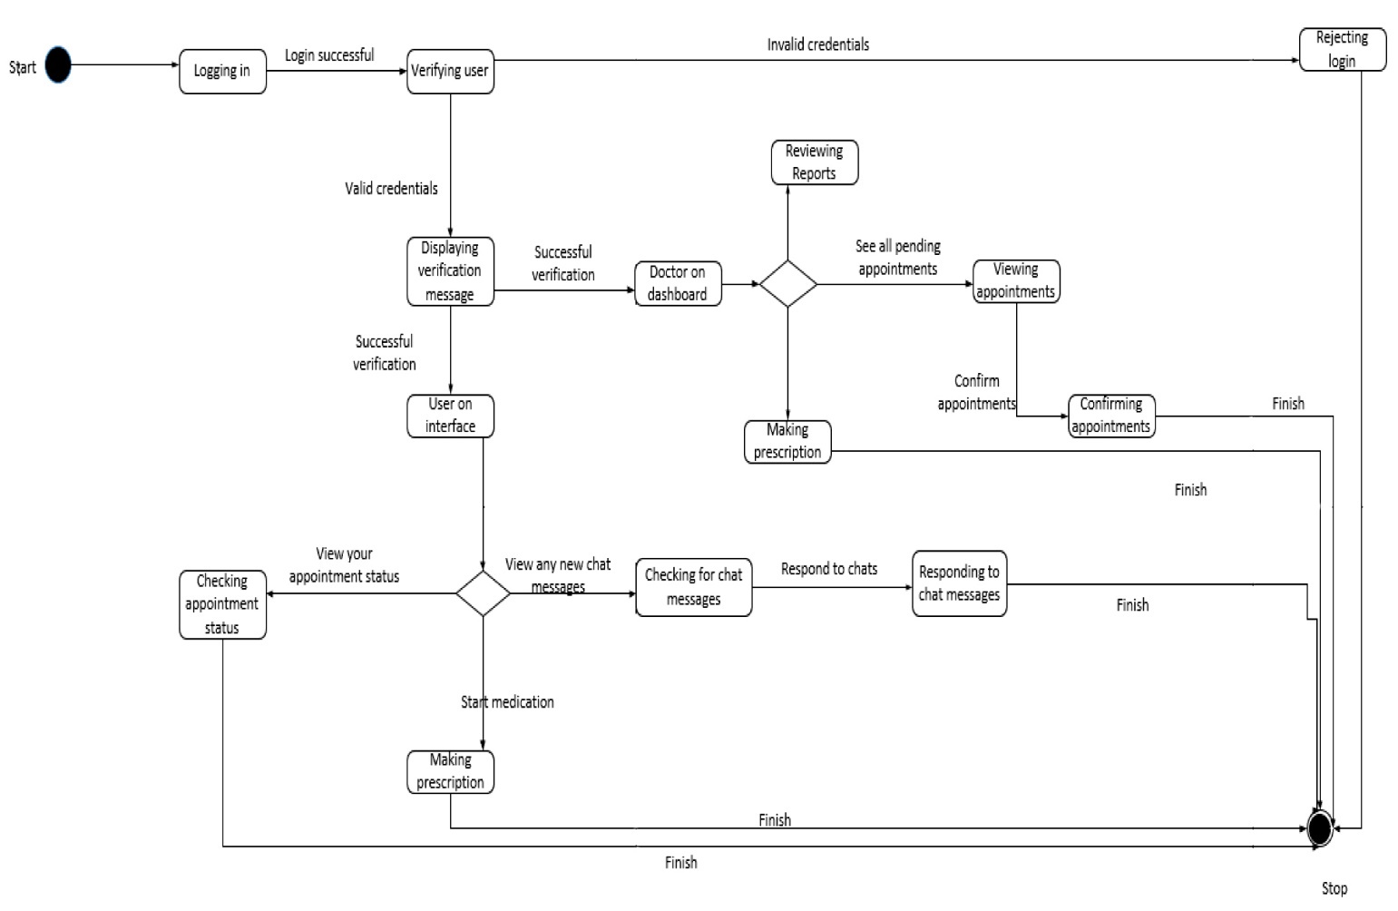

Figure 4.2 3 : State Chart Diagram

**Chapter 5**

# System Implementation, Testing, and Validation

## 5.1 Data Outputs

During the implementation and testing phase of the Sickle Cell Disease Management System, various data outputs were generated. These outputs include system forms and screenshots that provide a visual representation of the system's functionalities and interface.

### **5.1.1 System Forms**

The system forms are interactive components of the Sickle Cell Disease Management System that allow users to input and retrieve information. These forms capture essential data related to patient registration, appointment scheduling, medication management, weekly reporting, and communication. The data collected through these forms is stored and processed to facilitate effective disease management.

Some of the system forms include:

1. **Patient | Care giver Registration Form:** This form collects patient information such as name, patient number for easy identification, contact details, medical history, address, date of birth, country of Residence for the patient or Caregiver, the Blood Type of the patient, Sickle Cell type, image and emergency contacts.

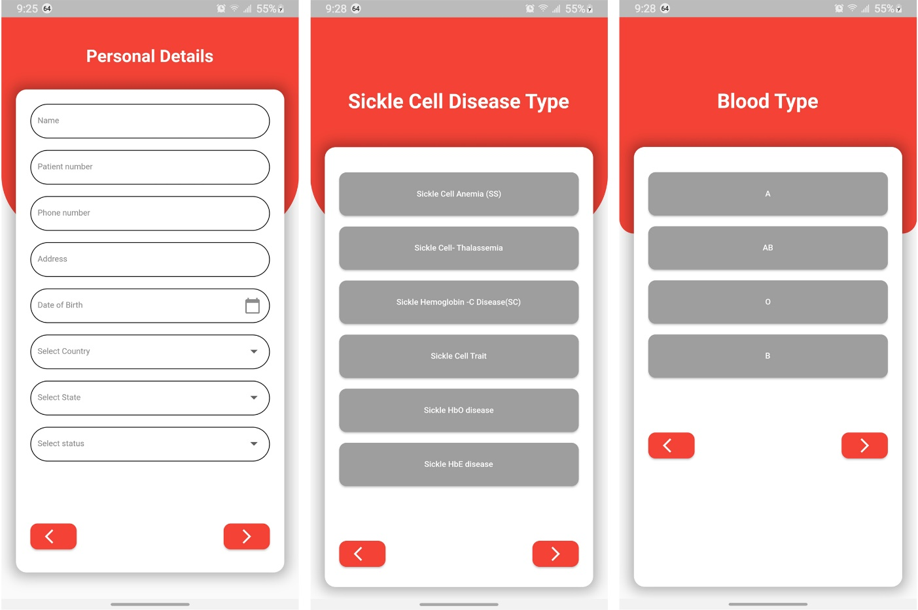

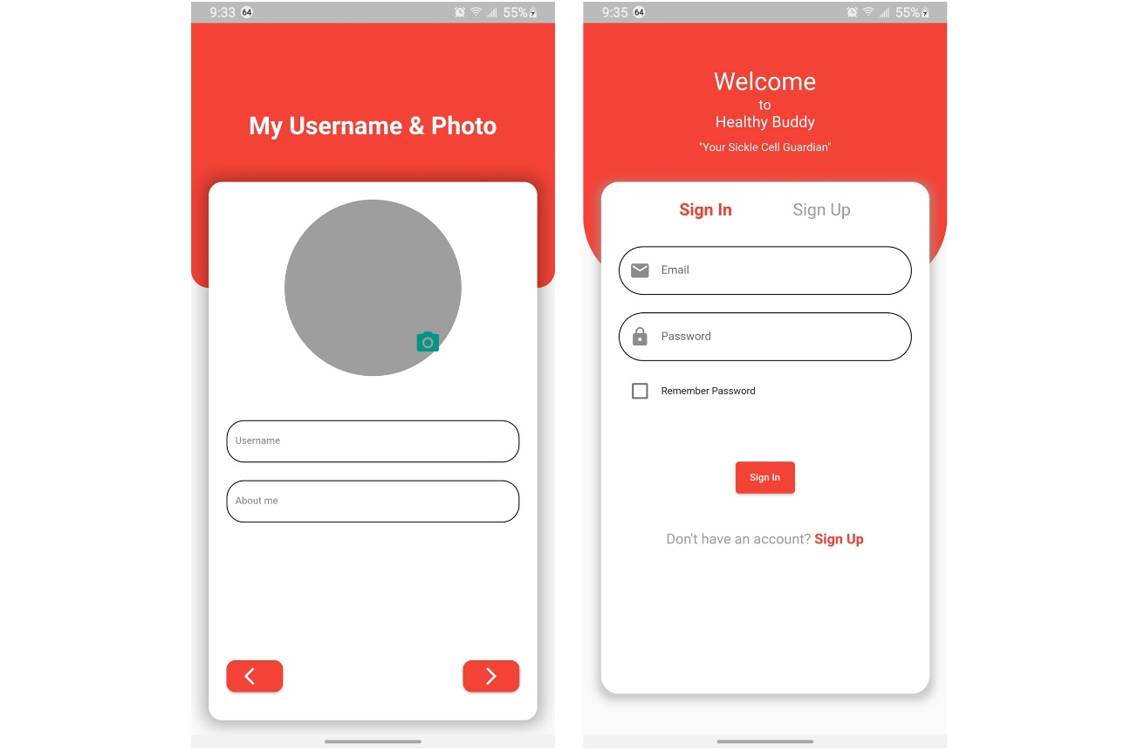

figure 5. 1: Showing a Patient / Care giver Registration form.

1. **Appointment Scheduling Form:** Patients use this form to schedule appointments with doctors, providing details such as preferred date and time for the Appointment, the treatments and the Reminder time in order to enable the System to make an alert to the Patient.

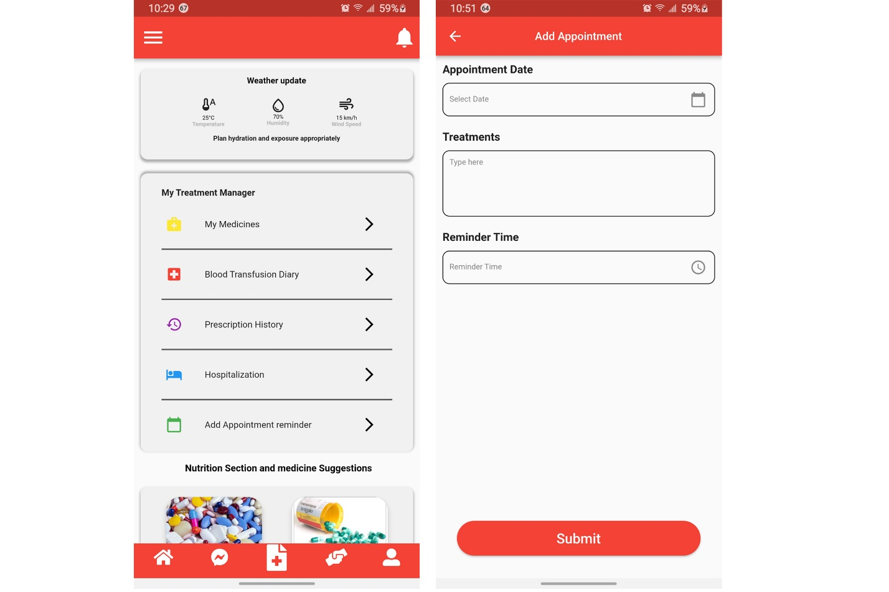

figure 5. 2: Showing the Appointment Form

1. **Medication Management Form:** Patients input their medication details, including prescribed medications, medicine type, the strength of the medicine, the duration or period in which the medicine must be taken, instructions of the medicine dosage, and frequency of intake.

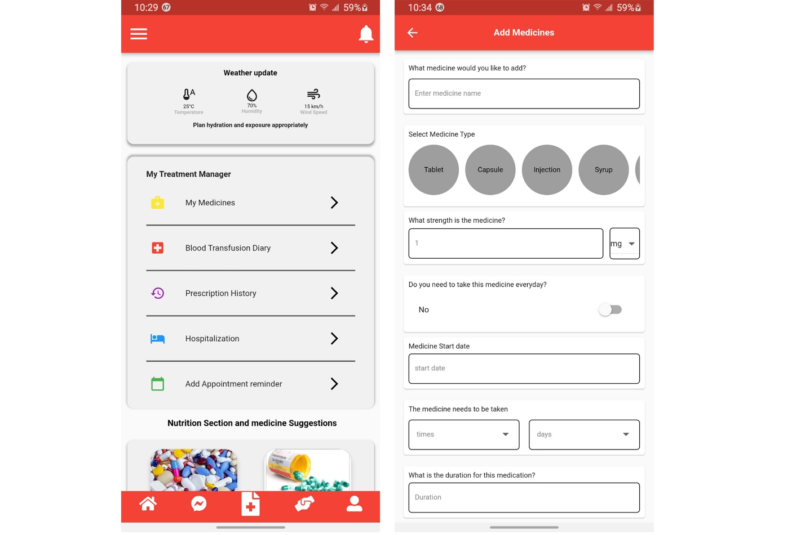

figure 5. 3: Showing the Medication Form

1. **Weekly Report Form:** Patients submit weekly reports on their condition, symptoms, medication adherence, and any abnormalities experienced. Within this form, the Patient inputs their general feeling, the pain episodes received in case of any, the description of the Episodes and information about any Critical attack in case of any.

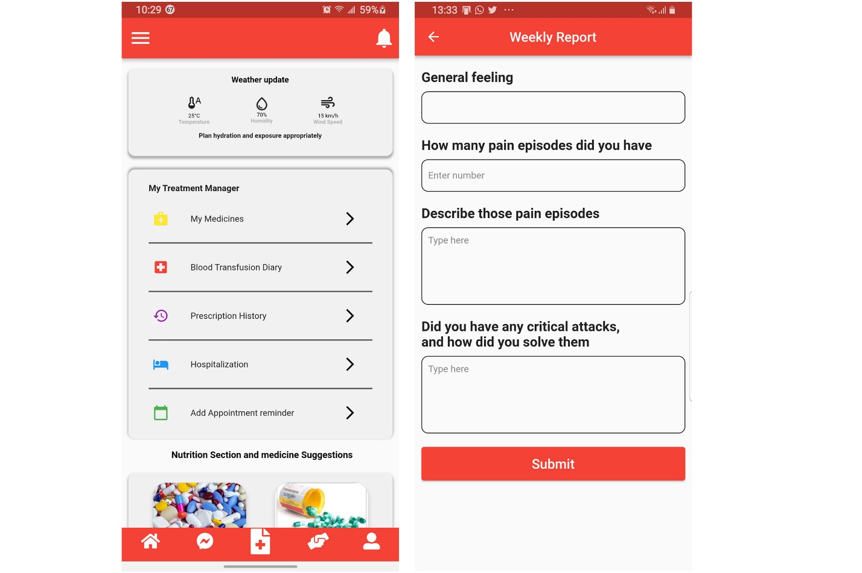

figure 5. 4: Showing the Weekly Report Form

1. **Communication Form:** This form allows patients to send messages to doctors and receive responses, facilitating effective communication.

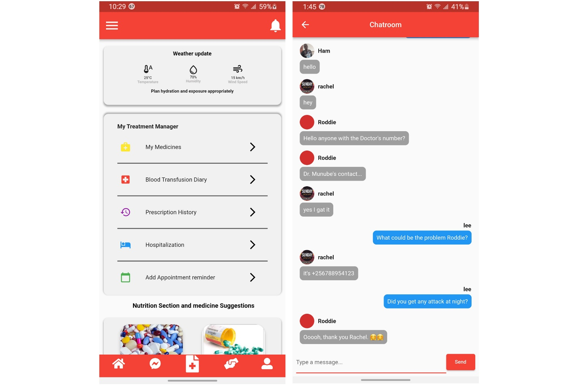

figure 5. 5: Showing the Communication Form

These system forms serve as important data inputs for the Sickle Cell Disease Management System, enabling effective tracking, monitoring, and communication between patients, caregivers, and healthcare providers.

Some of the doctor’s dashboard forms include:

1. **The log in form**: The doctor logs into the system by providing the user credentials given to him by the system administrator to access the system.

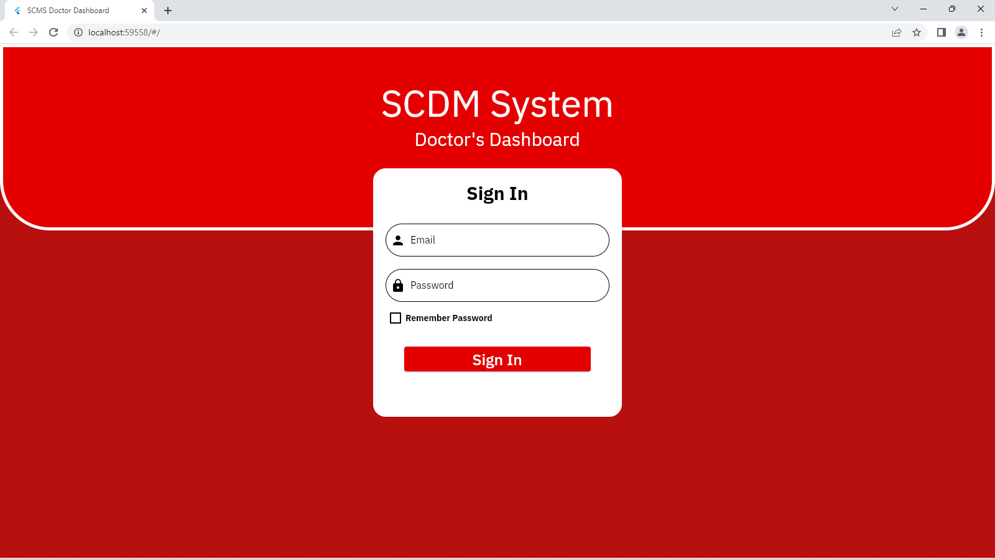

figure 5. 6: Login Form

1. The Make prescription Form: While on this form, the doctor is able to add prescription of the medicine given to the patient while including the duration the patient has to take the medicine, the time periods the patients has to take the dosages and then the submit button is pressed, the patient can see the prescription from the doctor immediately and in that way, the patient can manage he or her dosage in-take.

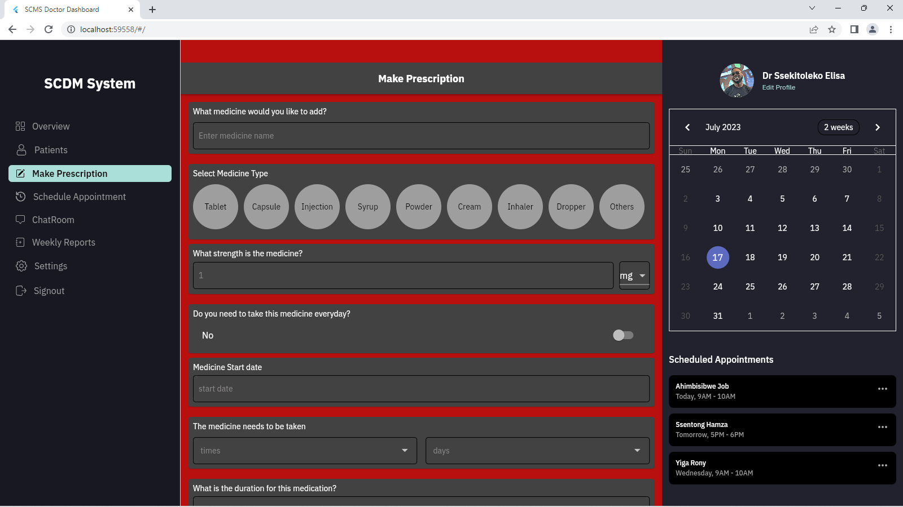

figure 5. 7: Make Prescription Form

1. Schedule Appointment form: The doctor schedules the next appointment date for the patient after selecting the patient’s name and also adds the reminder time so that the patient can be reminder about the appointment.

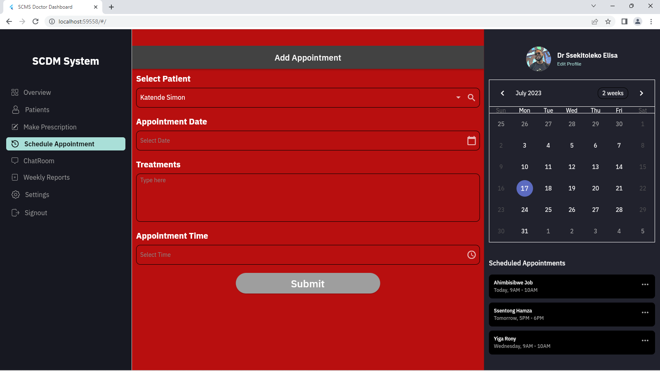

figure 5. 8: Make Appointment Form

**5.1.2 System Screenshots**

System screenshots provide visual representations of the user interface and functionalities of the Sickle Cell Disease Management System. These screenshots capture different sections of the system, showcasing its design, layout, and features. The screenshots offer a glimpse into the system's appearance and user interaction.

Some of the patient/caregiver mobile application screenshots include:

1. **Login Page:** This screenshot displays the login page where users can enter their credentials to access the system. These include the email and the password.

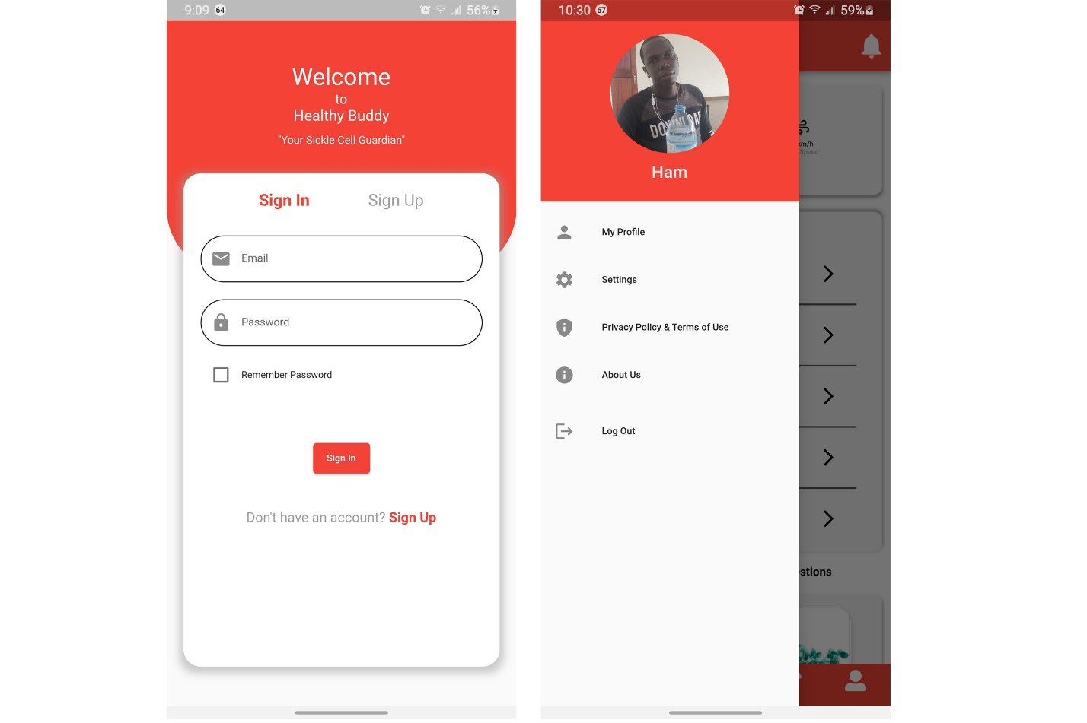

figure 5. 9: Showing the Login Interface.

1. **Appointment Scheduling Interface:** This screenshot illustrates the interface for scheduling appointments, allowing users to select the desired date and time.

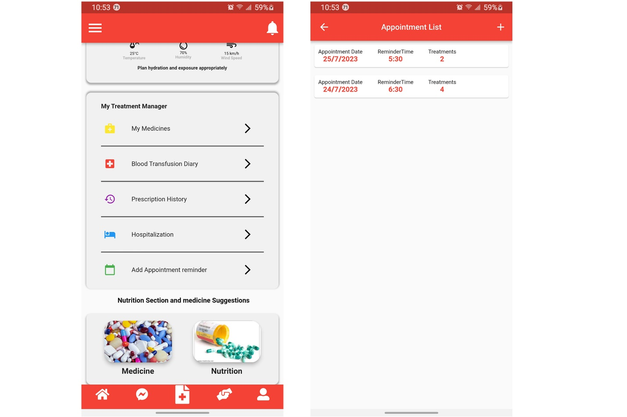

figure 5. 10: Showing the Appointment List Interface

1. **Medication Management Interface:** This screenshot showcases the medication management interface, where users add, track, and manage their medication details. A list of medication is provided in the interface below;

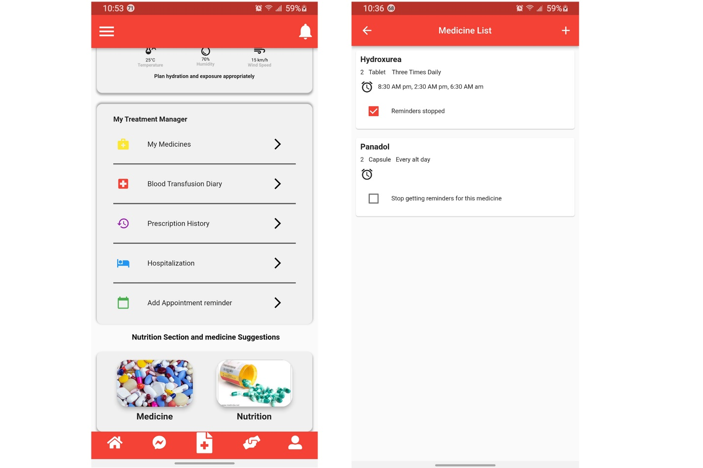

figure 5. 11: Showing the Medication List Interface

1. **Weekly Report Submission Form:** This screenshot presents the form for submitting weekly reports, allowing users to provide updates on their condition. The interface shown below provides the option for updating the Weekly Report in case of an error and the list of Weekly Reports made.

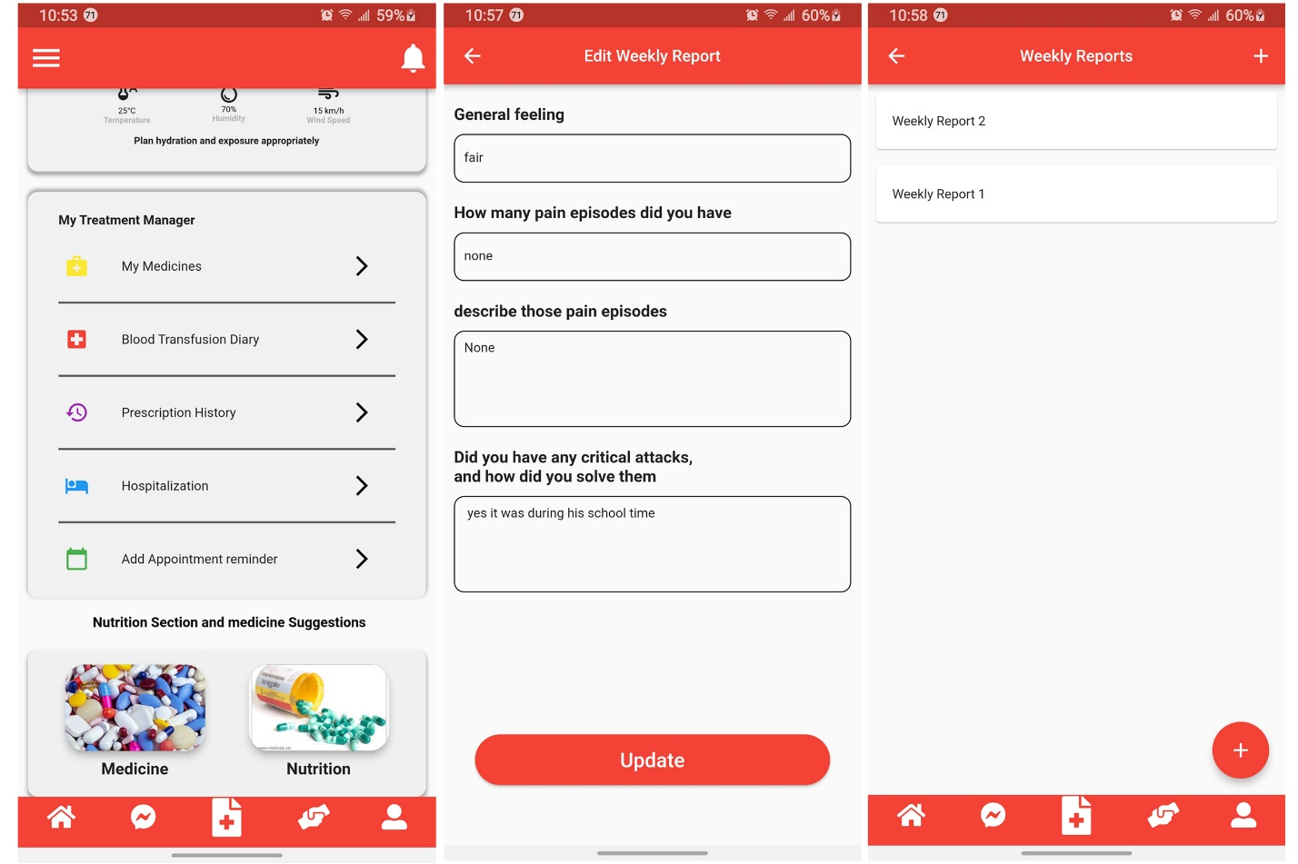

figure 5. 12: Showing the Weekly Report List Interface

1. **Messaging Interface:** This screenshot depicts the interface for communication between patients and doctors as well as between the fellow patients or Care givers, enabling them to exchange messages.

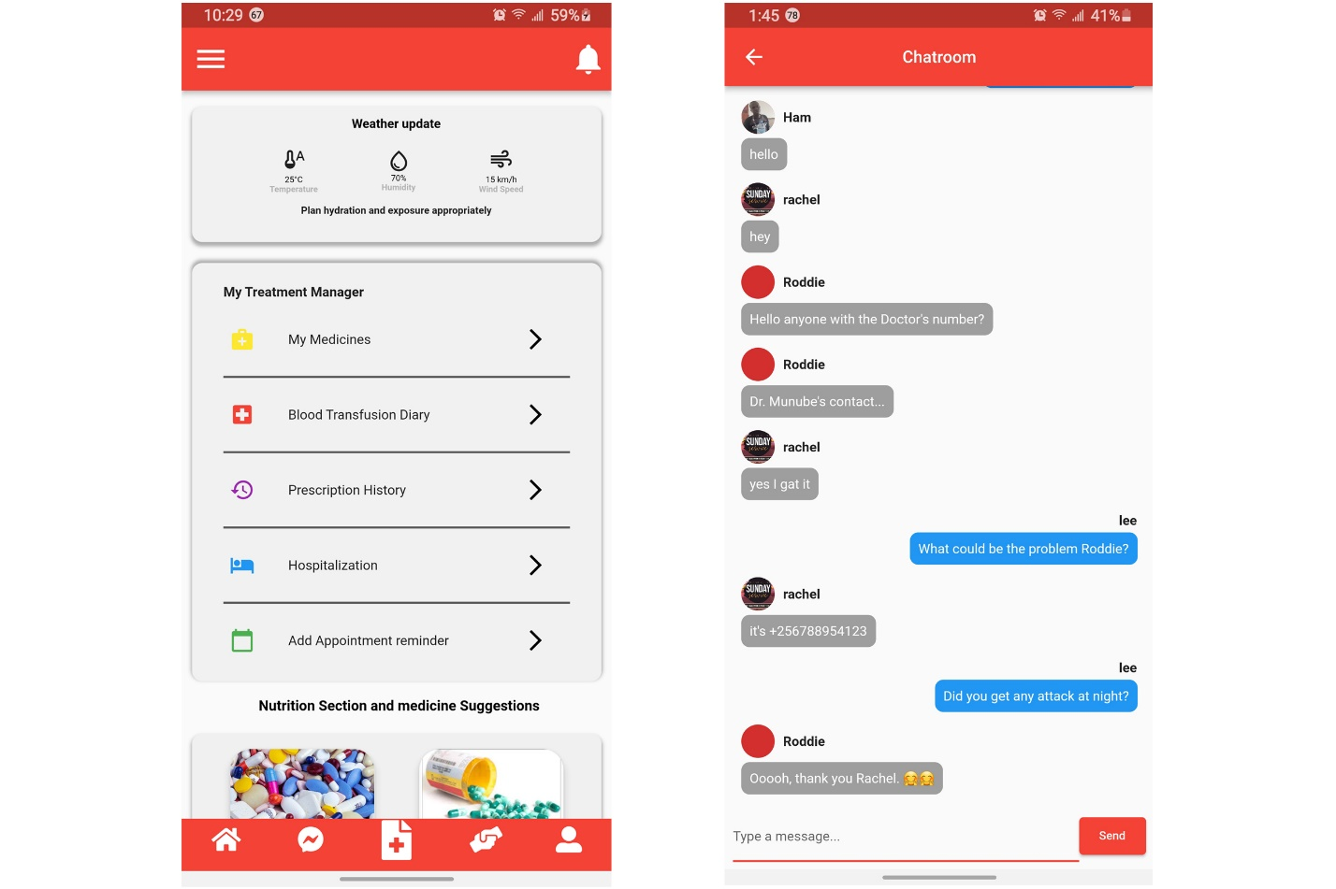

figure 5. 13: Showing the Chat Room Interface

These system screenshots offer a visual representation of the Sickle Cell Disease Management System, giving insights into its user interface and functionality.

Some of the doctor’s dashboard screenshots include;

1. The dashboard: The screen has an overview of everything the doctor can see and do on the application

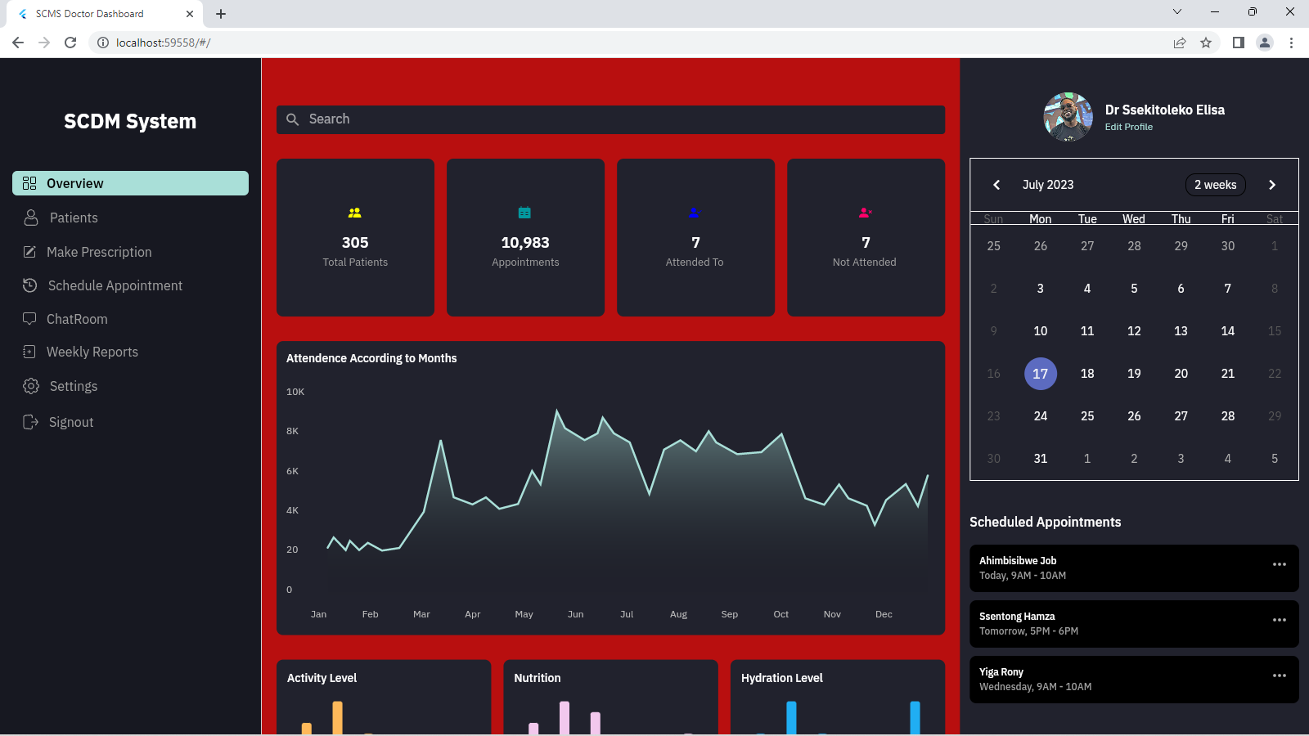

figure 5. 14: The Dashboard

1. The patients screen: While on this screen, the doctor can search and select a patient whose data he or she wishes to see, data such as hospitalizations, blood transfusion among others.

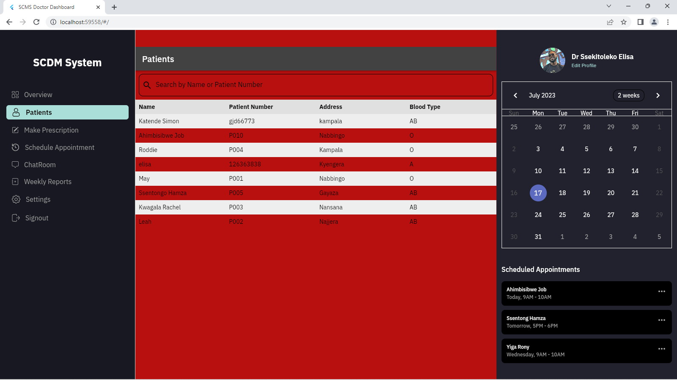

figure 5. 15: Patient Screen

1. The weekly reports screen: This screen shows the doctor all the patients who send he or her weekly reports and upon selection of the patient by name, the doctor is able to see all the weekly reports sent by that patient whose name has been selected.

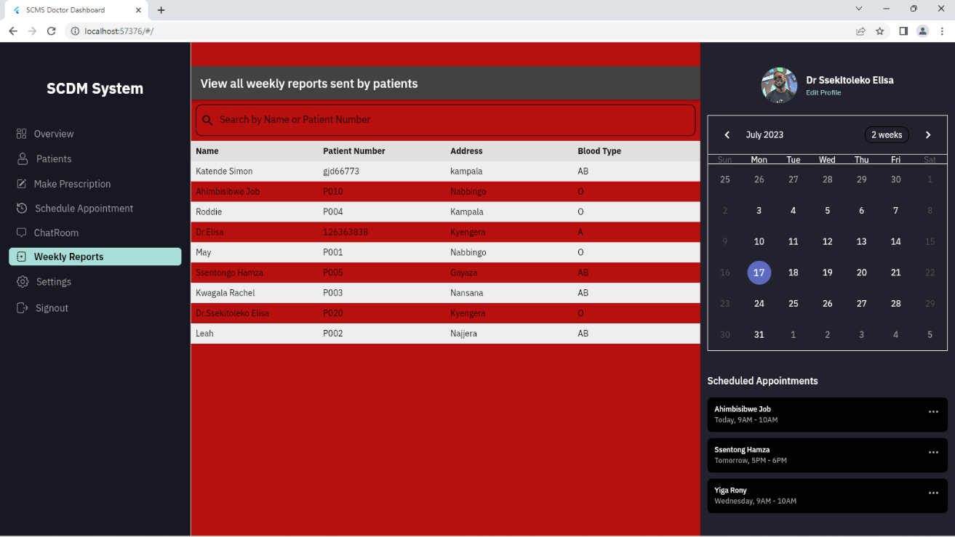

figure 5. 16: Weekly report screen

1. The Chatroom: This screen enables the doctor to chat with the patients whenever he has sometime so that he or she can see how his or her patients are coping with the disease or chat about other issues.

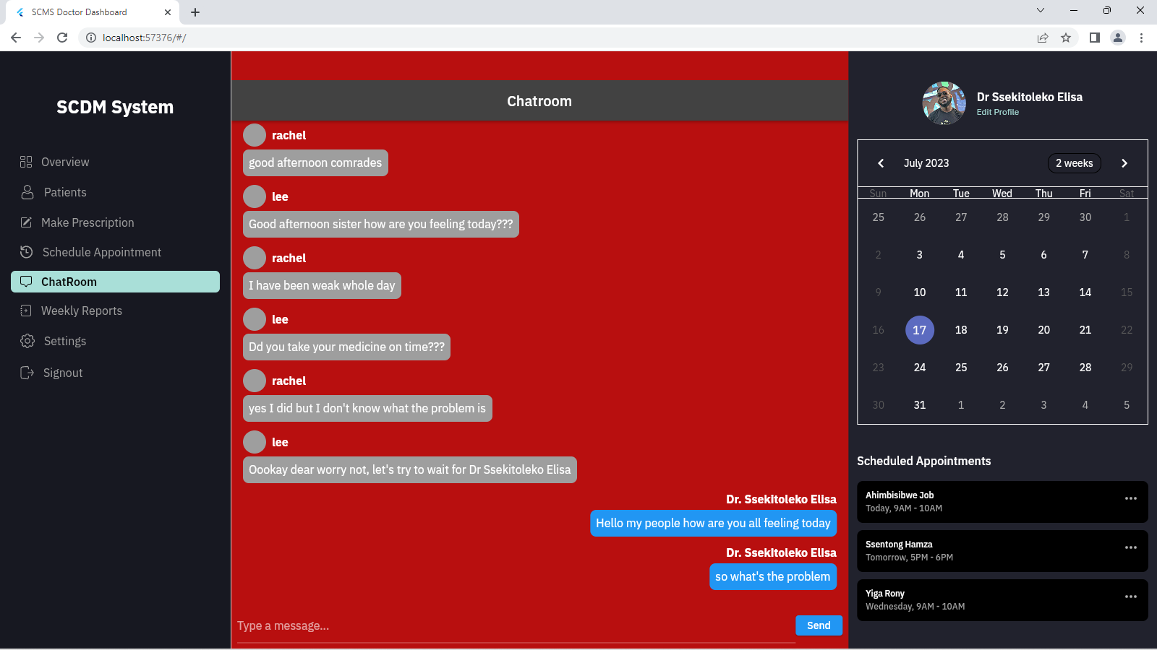

figure 5. 17: Chatroom

## 5.2 Programming Languages Used

During the implementation phase, several programming languages were utilized to develop the Sickle Cell Disease Management System. These languages enabled the creation of both the web and mobile applications, ensuring a robust and comprehensive solution.

### **5.2.1 Web Application Programming Languages**

The web application was developed using the following programming languages:

1. **Flutter:** Flutter, an open-source UI toolkit by Google, was utilized for building the mobile application. Flutter allowed for the development of a single codebase that could be compiled into native applications for both iOS and Android platforms.
2. **Dart:** Dart served as the programming language for developing the mobile application using the Flutter framework. Dart provided the necessary tools and libraries for creating responsive and performant mobile applications.
3. **Firebase:** Firebase was used as the database management system for storing and retrieving data related to patients, appointments, medication, and other system components.

These programming languages formed the foundation of the web application, ensuring its functionality and responsiveness.

### **5.2.2 Mobile Application Programming Languages**

The mobile application was developed using the following programming languages:

1. **Figma:** This was used for designing the user interface and creating visual mockups of the web application.
2. **Flutter:** Flutter, an open-source UI toolkit by Google, was utilized for building the mobile application. Flutter allowed for the development of a single codebase that could be compiled into native applications for both iOS and Android platforms.
3. **Dart:** Dart served as the programming language for developing the mobile application using the Flutter framework. Dart provided the necessary tools and libraries for creating responsive and performant mobile applications.
4. **Firebase:** Firebase was used as the database management system for storing and retrieving data related to patients, appointments, medication, and other system components.

The combination of Flutter and Dart enabled the development of a cross-platform mobile application that offered consistent functionality and user experience across different devices.

## 5.3 The Tools

Various tools and frameworks were employed during the implementation of the Sickle Cell Disease Management System. These tools facilitated efficient development, testing, and deployment of the system, ensuring its reliability and usability.

### **5.3.1 Web Development Tools**

The following tools were used for web application development:

1. **Flutter:** Flutter, an open-source UI toolkit by Google, was utilized for building the mobile application. Flutter allowed for the development of a single codebase that could be compiled into native applications for both iOS and Android platforms.
2. **Dart:** Dart served as the programming language for developing the mobile application using the Flutter framework. Dart provided the necessary tools and libraries for creating responsive and performant mobile applications.
3. **Firebase:** Firebase was used as the database management system for storing and retrieving data related to patients, appointments, medication, and other system components.

### **5.3.2 Mobile App Development Tools**

The primary tool used for mobile application development was Flutter. Flutter's comprehensive development environment, including the Flutter SDK, Dart programming language, and Flutter framework, provided the necessary tools for designing and implementing the mobile application. Additionally, Android Studio and XCode were used as integrated development environments (IDEs) for compiling and testing the mobile application on Android and iOS platforms, respectively.

## 5.4 System Testing

System testing is a crucial phase to ensure the quality, functionality, and reliability of the Sickle Cell Disease Management System. Various testing methods and techniques were employed to validate the system's performance and usability.

### **5.4.1 Unit Testing**

Unit testing was conducted to test individual components and functionalities of the system. Each unit, such as a specific module or function, was tested in isolation to verify its correctness and ensure it performed as expected. Test cases were designed and executed to validate the functionality of different system components.

### **5.4.2 Integration Testing**

Integration testing was performed to test the integration and interaction between different modules and components of the system. This testing ensured that the modules worked seamlessly together and that data was accurately exchanged between them. Test cases were designed to validate the integration and communication between different parts of the system.

### **5.4.3 System Testing**

System testing involved evaluating the system as a whole to ensure it met the specified requirements and performed its intended functions. Test scenarios were executed to validate the overall functionality, usability, and performance of the system. This testing phase focused on identifying any issues or discrepancies in the system and resolving them before deployment.

### **5.4.4 User Acceptance Testing**

User acceptance testing involved involving the target users, including patients, caregivers, and healthcare providers, to test the system and provide feedback. This testing aimed to ensure that the system met their needs and expectations. Users were asked to perform various tasks and provide feedback on the system's usability, functionality, and overall user experience.

## 5.5 Validation

Validation of the Sickle Cell Disease Management System was carried out to ensure its compliance with the specified requirements and objectives. The system's functionalities, performance, and user experience were evaluated against the initial goals and user feedback.

**Chapter Six**

# Discussion, Recommendations, Future work and Conclusions

## 6.1 Discussion

This chapter concludes the report by highlighting the achievements, outlining the challenges encountered during the development and suggesting recommendations regarding this project.

**Achievements**

We were able to achieve the following objectives:

Improved collaboration among patients and doctors through messaging.

Information Sharing through the various health related sites.

Fundraising through support groups for donations.

Real time tracking of patients.

## 6.2 Limitations

As much as we were able to obtain the above stated achievements, we encountered several challenges as discussed below:

As students, our resources are really constrained. We faced enormous financial challenges during the data collection, printing and binding of the work and also high data costs as we tried to improvise and work through the pandemic.

During data gathering, some respondents were reluctant and biased to provide information needed for the development of the system.

This project is run along other course units. Establishing a balance between the project and the other course units was always a challenge!

## 6.3 Recommendations Future work

Areas for future research include addition of more features as future researchers may find out from the users of the system. Also, future research into a mobile application for the same purpose can be undertaken.

## 6.4 Conclusion

The Sickle Cell Disease Management System was successfully designed and implemented to provide functionalities such as inbuilt reminders, treatment plan, making prescription and information sharing. We found a gap in the communication and interaction among the doctors and sickle cell patients/ caregivers and we sought after solutions for that gap. We undertook this endeavor successfully!

# References

1. Green, N. S., Mathur, S., Kiguli, S., Makani, J., Fashakin, V., LaRussa, P., ... & Mupere, E. (2016). Family, community, and health system considerations for reducing the burden of pediatric sickle cell disease in Uganda through newborn screening. Global Pediatric Health, 3, 2333794X166377 6.
2. Haywood, el at, 2014, An Unequal Burden: Poor Patient-Provider Communication and Sickle Cell Disease.(https://www.ncbi.nlm.nih.gov/pmc/articles/PMC4115582/) PMID: 24935607)
3. Oyedeji C, Strouse JJ. Improving the Quality of Care for Adolescents and Adults With

Sickle Cell Disease—It’s a Long Road. JAMA Netw Open. 2020;3(5):e206377. doi:10.1001/jamanetworkopen.2020.6377

1. Atim Atoku, C., Nekaka, R., Kawala Kagoya, E., VN Sennyonga, L., Iramiot, J. S., & Tegu, 2017. C. Psycho-Social Challenges Faced by Caretakers of Children and Adolescents Aged 0-19. Second Al-Sadiq International Conference on Multidisciplinary in IT and Communication Science and Applications (AIC-MITCSA), 2017, pp. 119-124, doi: 10.1109/AIC-MITCSA.2017.872300
2. Jjuuko, & Kidimu. (2020). Assessment of prescribing patterns and access to medicines for the management of sickle cell disease at Mulago National Referral Hospital, Kampala

District (Doctoral dissertation, Makerere University). http://hdl.handle.net/20.500.12281/13273

1. Venugopalan, J., Brown, C., Cheng, C., Stokes, T. H., & Wang, M. D. (2012). Activity and school attendance monitoring system for adolescents with sickle cell disease. In *2012 Annual International Conference of the IEEE Engineering in Medicine and Biology Society* (pp. 24562459).
2. D. H. Abd and I. S. Al-Mejibli, "Monitoring System for Sickle Cell Disease Patients by Using Supervised Machine Learning," 2017 Second Al-Sadiq International Conference on Multidisciplinary in IT and Communication Science and Applications (AIC-MITCSA), 2017, pp. 119-124, doi: 10.1109/AIC-MITCSA.2017.8723006.

SC, L. (2018). Mayo Clinic Family Health Book 5th Edition: Completely Revised and Updated.

1. Sanyaolu, A., Agiri, E., Bertram, C., Brookes, L., Choudhury, J., Datt, D., ... & Williams, M. (20 20). Current modalities of sickle cell disease management. *Blood Science*, *2*(04), 109-116.
2. Boyle, C. A., & Cordero, J. F. (2005). Birth defects and disabilities: a public health issue for the 2 1st century. *American Journal of Public Health*, *95*(11), 1884-1886.
3. Palermo, T. M., Zempsky, W. T., Dampier, C. D., Lalloo, C., Hundert, A. S., Murphy, L. K., Bakshi, N., & Stinson, J. N. (2018). Contemporary clinical trials, 74, 88–96. [**https://doi.org/10.1016/j.cct.2018.10.006**](https://doi.org/10.1016/j.cct.2018.10.006)
4. Curtis, K., Lebedev, A., Aguirre, E., & Lobitz, S. (2019). A Medication Adherence App for Children With Sickle Cell Disease: Qualitative Study. JMIR mHealth and uHealth, 7(6), e8130. https://doi.org/10.2196/mhealth.8130
5. Essack, M., Radovanovic, A., & Bajic, V. B. (2013). Information exploration system for sickle cell disease and repurposing of hydroxyfasudil. PloS one, 8(6), e65190. https://doi.org/10.1371/journal.pone.0065190
6. Nicole M Alberts, et al 2020 May 8, JMIR Mhealth Uhealth PMCID:PMC7245000, PMID:32383683. Development of the InCharge Health Mobile App to Improve Adherence to Hydroxyurea in Patients With Sickle Cell Disease: User Centered Design Approach. Ncbi.nlm.nih.gov/pmc/articles/PMC7245000/#__ffn_sectitle
7. Hood, A. M., Nwankwo, C., McTate, E., Joffe, N. E., Quinn, C. T., Peugh, J. L., & Crosby, L. E. (2020). Mobile health use predicts self-efficacy and self-management in adolescents with sickle cell disease. Blood, 136, 57-58.

1. Shelly, G. B., & Rosenblatt, H. J. (2011). Systems analysis and design. Cengage Learning.
2. Simplilearn. (2022). What is data collection: Methods, types, tools, and techniques.

Retrieved from <https://www.simplilearn.com/what-is-data>-collection-article.

1. CDC. (2009). Data collection methods for evaluation: Document review (no. 18). Retrieved from <http://www.cdc.gov/healthyyouth/evaluation/>pdf/brief18.pdf

1. Paula T. Ross and Nikki L. Bibler Zaidi, 2019 Jul 25. Limited by our Limitations

(PubMed Central) <https://www.ncbi.nlm.nih.gov/pmc/articles/PMC6684501/>

10.1007%2Fs40037-019-00530-x

# Appendices

## Time framework budget for the development of the Sickle Cell Disease Management System

|  |  |  |  |
| --- | --- | --- | --- |
| **No.** | **DATE** | **PERSON** | **PARTICULARS** |
| 1. | 1st Nov 2022 To  1st Dec 2022 | All Group Members | Coming up with the topic of the Research.  Writing a Proposal of the selected Research topic.  Confirming with the Final Year Project Supervisor. |
| 2. | 2nd Dec 2022  To  20th Dec 2022 | All Group Members | Selecting the Research Case Study area which is Mulago Sickle Cell  Clinic.  Visiting the Case Study area for carrying out Research. Making consultations from the Lecturers and the Supervisor about the flow of our Project. |
| 3. | 28th Dec 2022  To  12th Jan 2023 | All Group Members | Editing the Research proposal as being recommended to us from the Lecturer and the Supervisor.  Having the Final Research Proposal sig  ned by Mr. Bitwire Albert. Finally handing in our Research Proposal for the Final Year Project. |

## Financial budget for the development of the Sickle Cell Disease Management System

|  |  |  |  |  |
| --- | --- | --- | --- | --- |
| **No.** | **ITEM** | **QUANTITY** | **UNIT PRICE** | **AMOUNT** |
| 1. | Research Books | 5 | 5,000 | 25,000 |
| 2. | Pens | 5 | 500 | 2,500 |
| 3. | Internet Bundles | 40 GB | 5,000 | 200,000 |
| 4. | Transport | 5 (Researchers) | 50,000 | 250,000 |
| 5. | Research Assistance Services  (Secretarial, Photocopying,  Printing, Binding etc.) | Numerous | 100,000 | 100,000 |
| 6. | Consultation Fee | Numerous | 50,000 | 50,000 |
| 7. | Feeding | 5 (Researchers) | 30,000 | 150,000 |
| 8. | Purchase of Licenses | 5 | 10,000 | 50,000 |
| 9. | Purchase of Mobile Money API (USSD Code) | 2 | 50,000 | 100,000 |
| 10. | Miscellaneous |  | 100,000 | 100,000 |
|  | TOTAL |  |  | 1,702,500 |

## Data collection Instruments.

### **Questionnaire with closed questions.**

1. How long have you been living with sickle cell disease?
2. Less than 1 year
3. 1-5 years
4. 5-10 years
5. Over 10 years
6. How often do you visit a healthcare provider for your sickle cell disease?
7. Monthly
8. Every 3 months
9. Every 6 months
10. Less than once a year
11. Do you currently use any technology or system to manage your sickle cell disease?
12. Yes
13. No
14. Not sure
15. How satisfied are you with the current system you use for managing your sickle cell disease?
16. Very satisfied
17. Somewhat satisfied
18. Neutral
19. Somewhat dissatisfied
20. Very dissatisfied
21. What features would you like to see in a sickle cell disease management system? (please tick all that apply)
22. Symptom tracking
23. Medication reminders
24. Communication with healthcare providers
25. Emergency document management
26. Telemedicine consultations
27. Support groups and forums
28. Appointment reminders
29. Progress reports
30. Other (please specify) ___________
31. How important is it for the sickle cell disease management system to be culturally and linguistically appropriate?
32. Very important
33. Somewhat important
34. Neutral
35. Not very important
36. Not at all important
37. How likely are you to use a sickle cell disease management system if it were available?
38. Very likely
39. Likely
40. Neutral
41. Unlikely
42. Very unlikely
43. Do you have any additional comments or suggestions about the proposed sickle cell disease management system?
44. Can we contact you if we have any follow-up questions?
45. Yes
46. No

### **Questionnaire with Open questions**

1. How have you been managing your sickle cell disease so far?
2. What are the biggest challenges you face when managing your sickle cell disease?
3. What are the most important features you would like to see in a sickle cell disease management system?
4. How do you think a sickle cell disease management system could improve your overall quality of life?
5. Can you provide an example of a time when you needed emergency care for a sickle cell disease crisis, but were unable to access it?
6. How do you currently communicate with your healthcare provider(s) about your sickle cell disease?
7. What are your thoughts on using telemedicine consultations as part of a sickle cell disease management system?
8. How important is cultural and linguistic appropriateness to you when it comes to a sickle cell disease management system?
9. Do you have any additional comments or suggestions about the proposed sickle cell disease management system?
10. Can we contact you if we have any follow-up questions?

## Interview Questions

1. Can you tell me about your experience living with sickle cell disease?
2. What are some of the biggest challenges you face when managing your sickle cell disease?
3. How often do you visit a healthcare provider for your sickle cell disease?
4. Are you currently using any technology or system to manage your sickle cell disease? If so, can you describe it?
5. Can you describe a time when you needed emergency care for a sickle cell disease crisis, but were unable to access it?
6. How do you currently communicate with your healthcare provider(s) about your sickle cell disease?
7. What are your thoughts on using telemedicine consultations as part of a sickle cell disease management system?
8. What are the most important features you would like to see in a sickle cell disease management system?
9. How important is cultural and linguistic appropriateness to you when it comes to a sickle cell disease management system?
10. How likely would you be to use a sickle cell disease management system if it were available?
11. Do you have any additional comments or suggestions about the proposed sickle cell disease management system?

•

System Testing

•

Unit Testing

•

Completing